General Introduction to SCOCOEX Global Week
A New Beginning, A Fresh Start
Event Title:
SCOCOEX GLOBAL WEEK 2028
SCOCOEX Global Week 1407
(Specialized, Commercial, and International)
Edition: First Year
Exhibition Organizer: Aftab Pishraft Sanat Company
Company Registration Code: 10101847288
Exhibition Dates:
April 12–18, 2028 (24–30 Farvardin 1407)
Venue:
Tehran International Exhibition Center (Iran), Oman Convention & Exhibition Centre (OCEC), Uzexpocentre (Uzbekistan), and Inter Expo Center (IEC), Sofia, Bulgaria.
Four-Nation Collaboration:
IRAN – OMAN – UZBEKISTAN – BULGARIA

Table of Contents
SCOCOEX GLOBAL WEEK (SGW2028)

1. Event Overview
- Introduction to SCOCOEX Global Week
- Event Title and Executive Information
- Dates, Venues, and Host Countries
- Four-Nation Partnership (Iran, Oman, Uzbekistan, Bulgaria)

2. Table of Contents
- Preliminary Document Outline

3. Event Features and Nature
- Key Features of SCOCOEX Global Week
- Event Structure and Value Chain Model
- Objectives of International Cooperation
- The Role of Countries and Global Organizations

4. International Scope and Global Participation
- Participation of 200 Countries Worldwide
- Invitations to World Leaders, Governments, and International Organizations
- Structure of Trade Delegations and Investment Missions
- Participating International Organizations and Associations

5. Exhibition and Event Structure
- Main Exhibition and Its Capabilities
- Number of Participants and Global Brands
- B2B / B2G / G2G Meetings
- Specialized Conferences and Congresses

6. Event Programs
- Annual and Seasonal Programs
- Specialized and Private Meetings
- Cultural Programs, Artistic Events, and SCOCOEX Nights
- Investment Marketplace and Joint Venture Projects (JV Market)

7. Philosophy, Identity, and Mission
- Official Definition of SCOCOEX
- Mission and Vision
- Sustainable Development and the Economy of Peace
- The Davos + Expo + CES + G20 Model

8. Symbolism and Visual Identity
- Logo and the Five-Continent Symbol
- The Concept of the Five Global Colors
- The Phoenix Symbol
- The Philosophy of Rebirth and Global Cooperation
- Official Slogan: Humanity, Peace, Global Economy
- National Symbols of the Host Countries (Oman, Uzbekistan, and Bulgaria)

9. Conceptual Design and Branding
- Logo Structure and Graphic Design
- Brand Messages and Economic Diplomacy
- Visual Identity Standards
- International Brand and Identity Messaging

10. Event Executive Structure
- Event Execution and Management Architecture
- Support Network (Technology, Media, and Logistics)
- Crisis Management and Safety
- Visitor Experience

11. Specialized Exhibition Halls
- Introduction to the 14 Exhibition Halls
- Future Hall, Innovation Hall, Brand Hall, Energy Hall, National Hall, and More
- Metaverse and Future Technologies Hall
- Projects and Investment Hall

12. Industrial and Economic Sectors
- Oil, Gas, and Petrochemical Industries
- Mining, Steel, Aluminum, and Metals
- Food, Agriculture, and Pharmaceutical Industries
- Technology, Artificial Intelligence, and ICT
- Transportation, Logistics, and Infrastructure

13. Target Countries
- List of 200 Invited Countries
- Countries from Asia, Europe, Africa, the Americas, and Oceania

14. Distinguished Guests and Human Capital Structure
- VIP and VVIP Structure
- Business Leaders, Government Officials, and Investors
- Participation of Universities and International Organizations

15. Economic Outcomes and Impact
- Economic Value of USD 2.5 Trillion
- Global Investment and Trade
- Economic Benefits and Revenue for the Host Countries

16. Governance Structure and Foundation
- SCOCOEX FOUNDATION
- Foundation Objectives and Global Role
- Investment Network and Project Development

17. Cultural and Symbolic Identity
- The Story of the SCOCOEX Phoenix
- Symbol of Unity, Peace, and Sustainable Development
- Official Multilingual Slogans

18. Standards and Operational Policies
- International Event Management Standards
- Security and Protocol Procedures
- Accommodation and Logistics Services for Participants

19. Conclusion and Future Vision
- The Global Vision of SCOCOEX
- Iran's Role in Shaping the Global Model
- The Future of the Event and the Expansion of the Global Network

General Introduction
Key Features of SCOCOEX Global Week
SCOCOEX Global Week is an international event that should not be missed. It provides a unique platform to experience the full spectrum of business opportunities and challenges, including trade, technology, investment, joint ventures, marketing, quality management, and customer-oriented communication and dialogue.
SCOCOEX is a comprehensive, value-chain-based international event held annually in one of the designated host countries. In addition to the main annual edition, several seasonal and thematic events are organized throughout the year, simultaneously taking place in one or more countries.
The permanent headquarters of SCOCOEX is located in Tehran. Should any member country be unable to meet the hosting requirements, Iran will serve as the official host for that year's event.
The event is centered around a 7-day main program, taking place within a 15-day operational period, including four days of pre-event activities and four days of post-event programs.
SCOCOEX establishes an innovative framework for legal and institutional cooperation in support of sustainable development. It facilitates collaboration in areas such as financial relations, customs, transportation, banking, insurance, international standards, and other strategic sectors. These frameworks are developed dynamically in response to the evolving needs and requirements of participants.
At SCOCOEX, participants gain access to a new global network of customers and communication channels spanning 200 invited countries. Member states of major international organizations—including:
BRICS, SCO, ECO, ICC, IORA, ILO, ICA, OPEC, GECF, OIC, WORLD ZFO, and AMF
—as well as countries maintaining Joint Chambers of Commerce with the host nation(s), together with their neighboring countries, are invited as principal participants to showcase their capabilities, products, services, technologies, and investment opportunities.
SCOCOEX is, in essence, an integrated international platform that brings together multiple strategic programs designed to create new business opportunities, strengthen commercial partnerships among companies, enhance cooperation between international organizations, support the establishment of international federations, and promote the exchange of knowledge, expertise, and best practices.

SCOCOEX with the Participation of 200 Countries
By bringing together 200 invited countries, SCOCOEX creates one of the world's largest international business platforms, representing a market of more than half of the global population.
As the host of this prestigious event, SCOCOEX extends official invitations to Heads of State, government officials, ambassadors, and representatives of national and international institutions, including ministries responsible for industry, mining, trade, agriculture, petroleum, foreign affairs, labor and social welfare, energy, and economy, as well as scientific and technology organizations, trade development agencies, central banks, engineering associations, port authorities, shipping companies, airlines, railway administrations, national standards organizations, chambers of commerce, chambers of cooperation, chambers of guilds, joint chambers of commerce, industrial and management associations, multinational corporations, super-holding companies, international investors, sovereign wealth funds, investment funds, banks, insurance companies, and major economic institutions.
The event also welcomes leading companies from strategic sectors, including oil, gas and petrochemicals, automotive, steel, aluminum, mining, food industries, textiles, apparel, retail chains, e-commerce, infrastructure development, residential, commercial and office construction, mega-project developers, airports, ports, railways, dams, tunnels, highways, smart cities, museums, free economic zones, universities, research centers, and innovation institutions.
More than 200 high-net-worth individuals (HNWIs) from five continents—including representatives from the United States, the United Kingdom, Germany, Canada, Denmark, Austria, the Netherlands, Norway, Iran, Oman, Uzbekistan, Saudi Arabia, the United Arab Emirates, Qatar, Brazil, China, Russia, and many other countries—are expected to participate.
SCOCOEX provides participants with a unique opportunity to establish direct relationships with business leaders, entrepreneurs, investors, and decision-makers from the 200 invited countries. Through these strategic connections, participants can create long-term partnerships that contribute to sustainable exports, international investment, and joint commercial ventures.
The event is carefully designed around the objectives of its sponsors and participants, offering a comprehensive framework for effective international business dialogue. It supports every stage of the commercial process, including customer identification, business matchmaking, contract negotiation, order fulfillment, banking and financial services, customs procedures, insurance, international standards, digital trade platforms, commercial strategies, market access, identification of trade barriers, and the development of practical solutions for international business challenges. Throughout the event, participants receive professional guidance from specialists in marketing, international negotiations, legal affairs, commercial contracts, finance, and global trade.
With the participation of distinguished guests representing more than 60 international organizations, unions, federations, agencies, and professional associations, SCOCOEX also recognizes outstanding entrepreneurs, innovators, economists, business leaders, and national achievers. According to the various themes of the event, gold medals, trophies, honorary awards, and distinguished recognitions will be presented to selected individuals and organizations.
The main exhibition of SCOCOEX Global Week is expected to host more than 1,500 leading companies, including global brands, industrial enterprises, holding companies, financial institutions, and technology providers, while introducing major national and international investment projects.
In addition to high-level summits and conferences, trade delegations from 200 countries will visit the exhibition to explore opportunities for purchasing goods, services, technologies, and industrial capabilities from Iranian, Omani, Uzbek, and other participating international companies. The exhibition will facilitate direct business negotiations, strategic partnerships, and investment opportunities.
More than 20,000 internationally recognized companies will be invited to participate in and become members of SCOCOEX Global Week. Membership will be available through an annual fee, starting at USD 50,000. Participation by company presidents and senior executives in executive meetings, summits, and conferences will range from USD 25,000 to USD 100,000 per participant, depending on the selected programs and level of participation.
SCOCOEX Global Week serves as an international platform to promote the export potential of oil and non-oil products, industrial capabilities, technologies, and services from Iran, Oman, Uzbekistan, and all participating countries. The organizers believe that, through collective expertise, strategic planning, and international cooperation, the event will significantly contribute to achieving the commercial objectives of participating countries—particularly the host nations—across target markets within international organizations and neighboring regions.
To ensure measurable outcomes, specialized commissions and country-focused committees will be established for each participating nation. These committees, supported by international experts, producers, leading brands, and representatives of the host countries, will conduct preliminary workshops, market assessments, demand analyses, and opportunity evaluations. Their objective is to identify each country's commercial potential and create a results-oriented framework for sustainable international trade and economic cooperation.

SCOCOEX General Programs
SCOCOEX organizes its flagship annual event, including high-level summits, executive forums, and an international exhibition, during the first month of each new calendar year, from December 1 to December 7, in a designated host country.
Approximately 3,500 selected members participate in the annual summits and forums. These participants include investors, business leaders, government officials, policymakers, economists, distinguished public figures, and members of the international media. Over a 15-day program, including 7 main event days and up to 8 nights, participants engage in more than 30 specialized conferences and approximately 800 private meetings (averaging four meetings per participating country) focused on international trade, investment, economic cooperation, and strategic global partnerships.
In addition to its flagship annual event, the SCOCOEX Foundation organizes regional exhibitions, thematic conferences, and seasonal events throughout the year.
The findings, recommendations, and official reports generated during these meetings are distributed to international organizations, heads of state, governments, and both member and non-member countries to support global economic cooperation and policy development.
The Foundation also actively engages its members in specialized initiatives by creating platforms that enable selected stakeholders, industry leaders, and strategic partners to participate in national and international projects, collaborative programs, and long-term investment opportunities.
SCOCOEX operates an integrated matchmaking platform that facilitates business networking, strategic collaboration, knowledge exchange, and technological innovation. Through physical, virtual, and metaverse-based environments, the platform manages and coordinates business meetings and professional interactions while addressing the rapidly evolving scientific and technological trends shaping the future of work, commerce, and communication.
The event receives extensive international media coverage from approximately 600 journalists representing more than 100 television and radio networks, newspapers, magazines, news agencies, and digital media platforms. Accredited media representatives receive full access to official sessions, many of which are also available through live online broadcasting.
Media representatives attending the event are issued Blue Accreditation Badges, while distinguished professional journalists receive Green Accreditation Badges, granting enhanced access to specialized programs and restricted areas.
The SCOCOEX Foundation is an independent, non-partisan, private-sector organization with no affiliation to any domestic or foreign political party. It operates nationally and internationally under the advisory framework of the economic and social offices of international organizations such as ECO, BRICS, and the Shanghai Cooperation Organization (SCO) in Iran, while maintaining coordination with the country's economic authorities, including the Ministries of Economy, Industry, Mine and Trade, and Foreign Affairs. The Foundation's highest governing authority consists of the Board of Directors of Aftab Pishraft Sanat Company, jointly serving with the Board of Trustees of the SCOCOEX Foundation.
Participants are selected through a targeted invitation process, focusing primarily on manufacturers, investors, buyers, exporters, importers, traders, and strategic business leaders from participating countries.

The Greatest Advantage of SCOCOEX Global Week
Beyond facilitating international business connections, the most significant value created by SCOCOEX is the enhancement of participants' global reputation and market positioning. Through meaningful exposure, executive networking, high-level meetings, and continuous engagement with international decision-makers, participants strengthen their brand recognition and establish a lasting presence in the minds of global audiences.
SCOCOEX delivers a professionally managed, development-oriented platform designed around the strategic objectives of its sponsors, partners, and participants, ensuring measurable business outcomes and sustainable international growth.

International Event Management Standards
SCOCOEX is organized in accordance with internationally recognized standards, including:
- Compliance with ISO and internationally accepted Event Management standards for event design, operations, safety, and service quality.
- Implementation of comprehensive health, safety, and security protocols for visitors, exhibitors, delegates, and staff.
- Delivery of a fully integrated physical and digital visitor experience, combining on-site participation with advanced online engagement.
- Compliance with international diplomatic, cultural, and protocol guidelines to ensure a world-class international event.

Event Execution Architecture
The operational framework of SCOCOEX consists of the following core components:
- Main Event Zones: Summit venues, exhibition halls, national pavilions, VIP lounges, and the International Investment Marketplace.
- Support Network: Dedicated teams responsible for technology, logistics, security, media relations, healthcare, and operational services.
- Visitor Journey Design: Clearly defined visitor routes, including general visitor pathways, VIP access routes, and dedicated media circulation areas.
- Digital Ecosystem: A comprehensive digital infrastructure featuring the official mobile application, online participation platform, live streaming services, virtual networking tools, and immersive interactive experiences.

Core Components of SCOCOEX Global Week
SCOCOEX Global Week consists of 12 major components, delivered simultaneously through an integrated and coordinated event framework:
- Official Summits and International Congresses
- Main Exhibition Featuring 30 Technology-Driven Industries
- Concurrent Specialized Exhibitions
- Continental and National Pavilions
- Joint Venture Investment Marketplace (JV Market)
- Cultural Heritage and Traditional Programs
- SCOCOEX Nights, Sports, and Artistic Events
- Educational Programs and Specialized Workshops
- SCOCOEX Global Awards Ceremony
- Exclusive VIP and Diplomatic Delegation Programs
- Public Cultural Activities
- Hot Air Balloon Experience

Eight Strategic Pillars of the Event
- Future Leadership, Governance, and Smart Cities
- Decision-Making and Knowledge Exchange
- Technology Showcase and Innovation Demonstrations
- Continental and National Pavilions
- Global Identity, Cultural Exchange, and Economic Cooperation
- Joint Venture Investment Marketplace (JV Market)
- Promotion of Innovation and Healthy Competition
- Networking Among Global Leaders and Decision-Makers

Event Value Chain
The SCOCOEX event is designed around a comprehensive value-chain model consisting of five principal stages:

Strategic Planning and Design
Defining the event's objectives, organizational structure, governance framework, and international operational standards.

Content, Technology, and Digital Infrastructure
Developing the digital ecosystem, including the official website, event platform, software systems, mobile applications, and participant services.

Event Execution and Coordination
Managing the day-to-day operation of summits, exhibitions, conferences, workshops, business meetings, and special programs.

Communications and Global Marketing
Coordinating international media relations, digital communications, social media engagement, branding campaigns, and worldwide promotional activities.

Evaluation and Documentation
Collecting operational data, participant feedback, performance indicators, and post-event reports to support continuous improvement and future strategic planning.

General Information – SCOCOEX Global Week
Event Type:
International event involving member states of international and regional organizations.
Event Programs:
- International Exhibition
- Official Summits
- International Conferences
- High-Level Forums
- Specialized and Executive Meetings
- Business Matchmaking Sessions
- Technical Visits
- Panel Discussions
- Educational Workshops
- Additional networking and professional programs
Official Conference Languages:
Persian and English
Exhibition Area:
Approximately 100,000–120,000 square meters, including both indoor and outdoor exhibition spaces.

Proposed Host Cities
The event is planned to be held simultaneously across 15 cities.

Iran
- Tehran
- Mashhad
- Isfahan
- Kish Island
- Anzali

Oman
- Muscat
- Salalah
- Sohar
- Nizwa
- Duqm

Uzbekistan
- Tashkent
- Namangan
- Samarkand
- Andijan
- Nukus
- Bukhara

Proposed Venues for Official Summits

Iran
- Saadabad Palace
- Niavaran Palace
- Summit Conference Hall
- Espinas Palace Hotel
- Olympic International Hotel, Tehran

Oman
- Al Alam Royal Palace
- Salalah Gardens Hotel
- Kempinski Hotel
- Shangri-La Barr Al Jissah Resort
- Al Bustan Palace, A Ritz-Carlton Hotel
- InterContinental Hotel
- Barceló Mussanah Resort
- Crowne Plaza Hotel
- Fanar Hotel
- Park Inn by Radisson
- Radisson Blu Hotel
- Salalah Rotana Resort
- Sheraton Oman Hotel

Uzbekistan
- Khudayar Khan Palace (Pearl Palace of Kokand)
- Hyatt Regency Tashkent
- Kukaldosh Boutique Hotel, Bukhara
- Suzani Hotel, Samarkand
- City Palace Hotel, Tashkent
- Sharq Plaza Hotel
- Prague Hotel, Tashkent

Visitor Experience

Registration and Entry
Fast and secure entry through digital ticketing and identity verification.

Visitor Guidance
Mobile application, interactive venue maps, navigation tools, and real-time event notifications.

Pavilion Experience
Easy access to exhibitor information, presentations, meetings, multimedia content, and participant networking.

Business Networking
Dedicated opportunities to meet global business leaders, investors, executives, and policymakers.

Post-Event Evaluation
Collection of visitor feedback and performance assessments to improve future editions.

Crisis Management and Safety

Crisis Management Team
Integrated teams responsible for security, healthcare, technology, logistics, and operational continuity.

Emergency Protocols
Comprehensive procedures covering fire safety, medical emergencies, crowd management, and emergency response.

Digital Continuity
Live streaming and online participation capabilities to ensure uninterrupted event operations in case of disruptions.

Personnel Training
Regular training programs and emergency simulations for staff and volunteers.

Invitations, Distinguished Guests, and Hosting Framework
SCOCOEX Iran hosts distinguished guests from 200 countries, including business leaders representing 50 to 500 of the leading companies from each country, presidents of chambers of commerce and joint chambers, leaders of free economic zones, mayors of major cities, founders of internationally recognized brands, technology entrepreneurs, executives of leading cooperative organizations, holding companies, banks, major industrial corporations, mining enterprises, internationally renowned athletes, artists, university presidents, scientific institutions, and representatives of international and regional organizations.
More than 35,000 official invitations are expected to be issued.
For approximately 3,500 selected distinguished guests, priority will be given based on the completion of registration requirements and application procedures. These invited participants will receive complimentary international airfare, accommodation, protocol services, hospitality, local transportation, and official tours. Other approved invitees will receive complimentary accommodation, protocol services, hospitality, and local tours.
Corporate participants, exhibitors, sponsors, keynote speakers, business delegation members, conference attendees, booth exhibitors, and general visitors will be admitted according to the applicable participation packages, sponsorship programs, exhibition fees, and registration categories.

Target and Invited Countries
The following countries and territories are invited to participate in SCOCOEX Global Week:
Afghanistan, Albania, Algeria, Andorra, Angola, Antigua and Barbuda, Argentina, Armenia, Aruba, Australia, Austria, Azerbaijan, Bahamas, Bahrain, Bangladesh, Barbados, Belarus, Belgium, Belize, Benin, Bermuda, Bhutan, Bolivia, Bosnia and Herzegovina, Botswana, Brazil, Brunei, Bulgaria, Burkina Faso, Burundi, Cabo Verde, Cambodia, Cameroon, Canada, Central African Republic, Chad, Chile, China, Colombia, Comoros, Republic of the Congo, Democratic Republic of the Congo, Costa Rica, Croatia, Cuba, Cyprus, Czech Republic (Czechia), Denmark, Djibouti, Dominica, Dominican Republic, Ecuador, Egypt, El Salvador, Equatorial Guinea, Eritrea, Estonia, Eswatini, Ethiopia, Fiji, Finland, France, Gabon, Gambia, Georgia, Germany, Ghana, Greece, Grenada, Guatemala, Guinea, Guinea-Bissau, Guyana, Haiti, Honduras, Hungary, Iceland, India, Indonesia, Iran, Iraq, Ireland, Italy, Jamaica, Japan, Jordan, Kazakhstan, Kenya, Kiribati, Kuwait, Kyrgyzstan, Laos, Latvia, Lebanon, Lesotho, Liberia, Libya, Liechtenstein, Lithuania, Luxembourg, Madagascar, Malawi, Malaysia, Maldives, Mali, Malta, Marshall Islands, Mauritania, Mauritius, Mexico, Micronesia, Moldova, Monaco, Mongolia, Montenegro, Morocco, Mozambique, Myanmar, Namibia, Nauru, Nepal, Netherlands, New Zealand, Nicaragua, Niger, Nigeria, North Korea, North Macedonia, Norway, Oman, Pakistan, Palau, Palestine, Panama, Papua New Guinea, Paraguay, Peru, Philippines, Poland, Portugal, Qatar, Romania, Russia, Rwanda, Saint Kitts and Nevis, Saint Lucia, Saint Vincent and the Grenadines, Samoa, San Marino, São Tomé and Príncipe, Saudi Arabia, Senegal, Serbia, Seychelles, Sierra Leone, Singapore, Slovakia, Slovenia, Solomon Islands, Somalia, South Africa, South Korea, South Sudan, Spain, Sri Lanka, Sudan, Suriname, Sweden, Switzerland, Syria, Tajikistan, Tanzania, Thailand, Timor-Leste, Togo, Tonga, Trinidad and Tobago, Tunisia, Turkey, Turkmenistan, Tuvalu, Uganda, Ukraine, United Arab Emirates, United Kingdom, United States of America, Uruguay, Uzbekistan, Vanuatu, Venezuela, Vietnam, Yemen, Zambia, Zimbabwe, Vatican City.

Additional Invited Territories and Special Administrative Regions (200 + 5)
In addition to the 200 invited countries, the following territories and special administrative regions are also invited to participate:
- Puerto Rico
- Hong Kong
- Greenland
- Faroe Islands
- Macau
- Foundations and Identity of SCOCOEX
- Definition, Objectives, and Mission
- 1. Foundations and Identity of SCOCOEX
- Official Definition of SCOCOEX
- SCOCOEX Global Week is a knowledge-driven and technology-oriented international platform dedicated to fostering sustainable economic cooperation. Its primary purpose is to facilitate large-scale economic collaboration, promote the exchange of knowledge, and connect global leaders, corporations, governments, and institutions in support of peace, prosperity, and sustainable development.
- The event brings together countries, multinational corporations, super-holding companies, financial institutions, universities, research organizations, and startups to develop joint economic, technological, and social initiatives that create long-term value and international partnerships.
- SCOCOEX represents a unique international model that combines the strategic dialogue of Davos, the global exhibition platform of Expo, the innovation ecosystem of CES, and the international policy cooperation of the G20, while maintaining its own independent identity and innovative framework. This concept and operational model were originally conceived and designed in Iran.

- SCOCOEX Global Week
- SCOCOEX Global Week is an international, knowledge-based and technology-driven event designed to promote large-scale economic cooperation, facilitate the exchange of knowledge, and connect world leaders, governments, international organizations, and leading corporations to advance peace, prosperity, innovation, and sustainable development.

Official Definition of SCOCOEX Global Week
SCOCOEX Global Week is an annual international gathering established to create a strategic networking platform connecting governments, cities, multinational institutions, super-holding companies, universities, financial institutions, startups, entrepreneurs, and global technology leaders.
Designed as a knowledge-driven and technology-oriented event, SCOCOEX focuses on stimulating large-scale economic cooperation, accelerating the development of future technologies, improving management excellence, and fostering collaboration among nations and institutions to advance global peace, prosperity, and sustainable development.
SCOCOEX Global Week is the first international economic cooperation event dedicated to bringing together member states of international organizations, countries maintaining Joint Chambers of Commerce with the host nation(s), and their neighboring countries. The event serves as a platform for promoting exportable products and services, expanding international trade, facilitating access to raw materials and advanced technologies for industrial modernization, attracting foreign direct investment, and encouraging joint investment projects.
The event is centered on empowering the private sector and knowledge-based enterprises, with the objective of creating wealth, generating employment opportunities, enhancing public welfare, and supporting sustainable socioeconomic development.
With the anticipated participation of more than 200 countries, SCOCOEX Global Week is planned to be held simultaneously in Tehran, Muscat, and Tashkent, while fully complying with international health, safety, and security protocols.
Recognizing the strategic importance of this international mega-event, SCOCOEX is expected to attract participation from ministries, government agencies, public institutions, multinational corporations, international organizations, economists, investors, and business leaders representing more than 200 countries.
SCOCOEX is designed as a value-chain international event. Its inaugural edition will be hosted jointly by Iran, Oman, and Uzbekistan, followed by a rotational hosting model involving additional countries in future editions. The long-term vision includes inviting Heads of State, senior government officials, and high-ranking international representatives to participate alongside the leadership of the host country.
The event provides an effective platform for informal diplomacy and international engagement by facilitating Government-to-Government (G2G), Business-to-Government (B2G), and Business-to-Business (B2B) meetings, accelerating strategic cooperation among governments, organizations, and the global private sector.

Permanent Headquarters
The permanent headquarters of SCOCOEX is located in Tehran, Iran.

Purpose and Founding Philosophy

Responding to Global Challenges
Today's world faces increasingly complex economic, technological, environmental, and social challenges that cannot be effectively addressed through traditional approaches alone.

The SCOCOEX Solution
SCOCOEX responds to these challenges by building a global network of governments, businesses, academic institutions, investors, innovators, and international organizations committed to developing transformative projects and long-term economic partnerships.

Core Values
The guiding principles of SCOCOEX are:
- Peace
- Shared Prosperity
- Sustainable Development
- Innovation
- Social Responsibility and Equity

A Human-Centered Vision
Every initiative, partnership, and program within SCOCOEX is designed with a human-centered approach, placing the advancement of people, communities, and future generations at the heart of economic and technological development.

Why SCOCOEX Matters
SCOCOEX Global Week introduces an original international model that combines the strategic dialogue of the World Economic Forum (Davos), the international exhibition ecosystem of the World Expo, the multilateral policy framework of the G20, and the innovation-driven environment of CES, while extending beyond each of these through its own multidimensional identity and integrated structure.
This is the first initiative of its kind to bring together such a broad, multilayered, and multidisciplinary global ecosystem under a single platform conceived and designed in Iran, with the potential to become one of the world's leading platforms for international cooperation.
SCOCOEX Global Week aims to create opportunities that could generate up to USD 2.5 trillion in economic potential for its strategic partners, participating businesses, investors, and international stakeholders.
The event provides a global platform where business leaders, technology pioneers, management experts, bankers, mayors, inventors, entrepreneurs, researchers, and policymakers can meet, collaborate, exchange ideas, and shape the future of international economic cooperation.

History of the Concept and Evolution of the SCOCOEX Model

Phase 1 – Concept Development (2010–2025)
The initial concept of SCOCOEX was developed through extensive research, benchmarking of leading international event models, and the formulation of a new global cooperation framework in Iran.
During this period, the founders conducted comprehensive field research and established international networks through numerous visits to countries including Türkiye, Russia, the United Arab Emirates, and others. These efforts focused on building strategic relationships, gaining practical insights into international economic cooperation, and expanding a global communications network.
In 2025, official authorization was obtained to organize the event under the title Iran SCOCOEX, with Iran serving as the host country for the inaugural edition.

Phase 2 – Global Structural Design and International Expansion (2026–2030)
The second phase focuses on transforming SCOCOEX into a comprehensive international platform by establishing a five-continent governance structure supported by five executive leadership seats, each representing one of the world's continents for strategic coordination and decision-making.
This stage includes:
- Building strategic international partnerships.
- Establishing internationally recognized operational standards.
- Expanding the global governance framework.
- Preparing for the official launch of SCOCOEX Global Week.
The inaugural international edition of SCOCOEX Global Week is planned to be held jointly in Iran, Oman, and Uzbekistan from 7–13 December 2026.

The Five-Color and Five-Continent Identity Framework
SCOCOEX adopts five primary colors to represent the five inhabited continents, reflecting the event's commitment to global cooperation and international unity.
Color | Continent | Symbolism
Green | Europe | Wisdom, Peace, and Innovation
Black | Africa | Sustainable Development and Natural Resources
Yellow | Asia | Technology and Dynamic Economic Growth
Red | The Americas | Leadership and Competitive Excellence
Blue | Oceania | Cooperation, Balance, and Global Connectivity
These five colors are incorporated throughout the SCOCOEX visual identity, including its logo, continental pavilions, publications, promotional materials, and event environments, symbolizing global unity and intercontinental collaboration.
When interwoven within the official logo, the five colors form the image of the Phoenix, representing the unity of nations across all continents. The Phoenix embodies the core mission of SCOCOEX: fostering international economic cooperation, sustainable growth, and the collective renewal of the global economy.
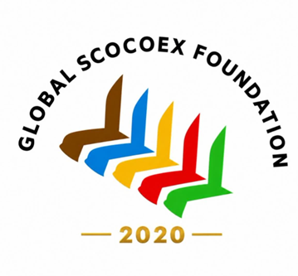

Symbolism of the SCOCOEX Foundation Logo
The SCOCOEX Foundation logo is designed to embody the organization's vision of global collaboration, innovation, and sustainable development. Each element of the logo represents a fundamental aspect of the Foundation's identity and mission.

The Five Executive Seats
The five executive seats symbolize collective leadership, global coordination, and shared decision-making across the world's five continents. They reflect SCOCOEX's commitment to inclusive governance, international cooperation, and balanced global representation.

The Unified Circle
The circular form represents unity, solidarity, and collaboration among nations, institutions, and people. It signifies the interconnected nature of the global economy and the shared responsibility of building a more prosperous and sustainable future.

The Five Colors
The logo incorporates the five official continental colors, each representing one of the world's inhabited continents. Together, they symbolize diversity, inclusion, cultural richness, and global convergence, reinforcing SCOCOEX's role as a platform that connects nations through cooperation and innovation.

The Overall Logo Design
The overall composition of the logo is a fusion of leadership, knowledge, and technology, illustrating the dynamic relationship between humanity and the future. It reflects SCOCOEX's mission to bridge governments, businesses, academia, innovators, and international organizations through a shared vision of sustainable economic development and global progress.
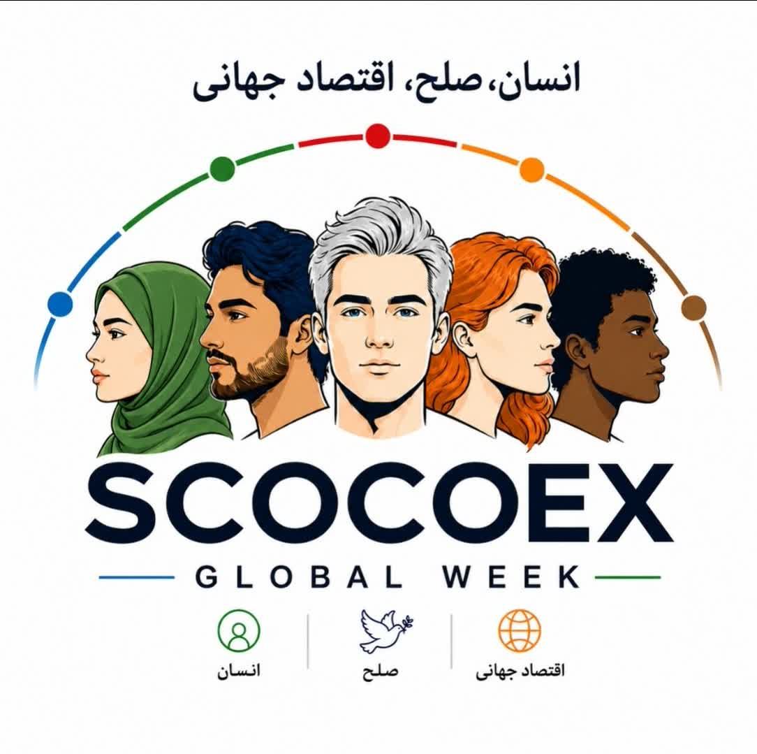

Semiotic Interpretation of the SCOCOEX Global Week Logo
From the perspective of semiotics, the SCOCOEX Global Week emblem conveys a powerful and universal message. Every visual element has been designed to communicate the event's philosophy of human-centered cooperation, peace, and sustainable global development.

1. Five Human Figures – A Symbol of Humanity in Unity
The five human figures at the center of the logo represent the world's five major continental and cultural regions:
- Asia
- Europe
- Africa
- The Americas
- Oceania
Their presence emphasizes a fundamental principle:
"The future of the global economy cannot be realized without the participation of all peoples and cultures."
By placing human figures at the center of the design, the logo conveys that humanity comes before economics. In other words, the economy should serve people—not the other way around.

2. Different Hair Colors – A Symbol of Cultural Diversity
The different colors of the figures' hair represent:
- Cultural diversity
- Ethnic diversity
- Linguistic diversity
- Civilizational diversity
Despite these differences, all five figures stand beneath a single unifying arc.
This expresses the principle of:
Diversity in Unity
One of the fundamental values of modern global diplomacy.

3. The Central Figure – A Symbol of the Future
The central figure, looking directly forward, represents:
- Future generations
- Shared global leadership
- A forward-looking vision
- Collective global responsibility
The remaining figures look in different directions, symbolizing the diverse perspectives, priorities, and interests of nations around the world.
Yet all remain united within one harmonious structure, illustrating that diversity of viewpoints can coexist within a framework of international cooperation.

4. The Colored Arc Above the Figures
The semicircular arc composed of colored elements symbolizes:
- The Earth
- A global network of cooperation
- International connectivity
- The pathway toward sustainable development
Its open semicircular form suggests that the world is continuously evolving and that the future is still being built through collective effort.

5. The Five Colors
The five colors represent the five foundational pillars of the SCOCOEX philosophy:
- Economy
- Technology
- Environment
- Peace
- Humanity
Together, they express the balanced integration of economic progress, technological innovation, environmental responsibility, peaceful cooperation, and human well-being.

6. The Official Motto: Humanity • Peace • Global Economy
The sequence of these three concepts is intentional and reflects the philosophical foundation of SCOCOEX.

Humanity
The starting point.
All economic policies, innovation, and international cooperation should ultimately improve the well-being of people.

Peace
The enabling foundation.
Without peace, sustainable trade, investment, innovation, and long-term prosperity cannot flourish.

Global Economy
The ultimate outcome.
When humanity and peace are placed at the center of international cooperation, a prosperous and sustainable global economy naturally follows.
Accordingly, the guiding philosophy of SCOCOEX is:
Humanity First
Peace Second
Global Economy Third

7. The Strategic Message of the Logo
In a single sentence, the logo communicates the essence of the SCOCOEX vision:
SCOCOEX is a global platform where humanity becomes the foundation, peace becomes the pathway, and the global economy becomes the outcome.

8. Symbolic Value as a Global Brand
The logo simultaneously communicates three core brand values:
- Global Inclusiveness
- Peace-Based Development
- Human-Centered Economy
These values align with the declared mission of SCOCOEX Global Week, positioning the logo as a powerful visual identity for a modern platform of international economic cooperation and global dialogue.

Iran's Role in the Creation of the Global Model

Concept Development
The original concept and foundational framework of the SCOCOEX model were developed and designed by Iranian teams through extensive research, strategic planning, and international benchmarking.

Prototype Development
The initial prototype—including the five-continent governance concept and the international cooperation platform—was developed, tested domestically, and presented to relevant international stakeholders as the basis for future global implementation.

Iranian Identity
The global identity of SCOCOEX is rooted in Iranian innovation, creativity, strategic thinking, and knowledge. This intellectual foundation represents an important contribution to the event's vision of international cooperation and sustainable economic development.
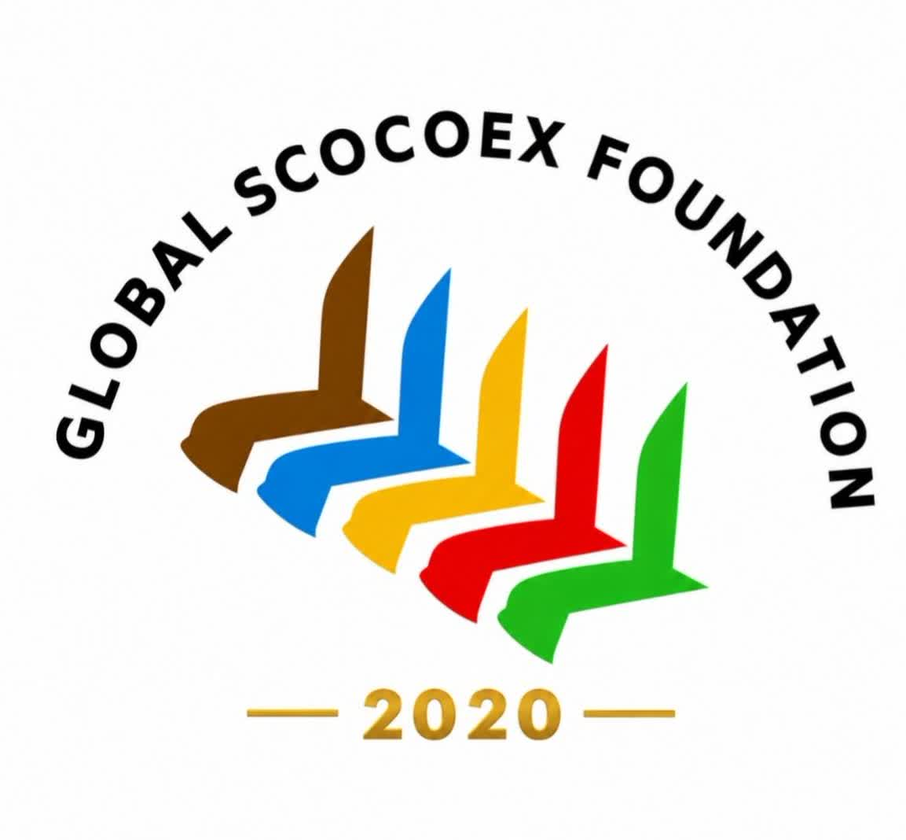

SCOCOEX at a Glance (One-Page Brief)
Official Name:
SCOCOEX
SMART & SPECIAL COOPERATION ORGANIZING CONFERENCE & EXHIBITION
Event Duration:
One week, conducted within a 15-day operational period, including four days of pre-event activities and four days of post-event programs.
Official Event Title:
SCOCOEX GLOBAL WEEK
Event Type:
An annual international and global event dedicated to expanding knowledge-based and technology-driven economic cooperation.
Operational Model:
A collaborative platform involving international organizations and member states of international organizations, designed to foster multilateral cooperation and sustainable economic development.
Participation Structure:
A global framework representing the five continents, symbolized by five executive leadership seats, supported by specialized continental and thematic pavilions.
Primary Participants:
- National governments and public institutions
- International organizations
- Super-holding companies and multinational corporations
- National and international enterprises
- Banks and financial institutions
- Universities and research centers
- Startups and innovation ecosystems
- Presidents of Chambers of Commerce, Industry, Cooperation, and Guilds
- Leaders of Free Economic Zones
- Mayors of major cities
- Museum directors and cultural institution leaders
- Scientists, researchers, and distinguished academic figures
- Influential leaders in business, technology, and innovation
- Women business leaders and entrepreneurs
- Executives of knowledge-based and technology-driven companies
- Prominent social, cultural, artistic, and sports personalities engaged in economic development
- Investors, policymakers, and other key decision-makers from around the world.

SCOCOEX Global Week (SGW) at a Glance – Key Statistics
SCOCOEX Global Week is envisioned as a Class A international event, designed in accordance with the standards and scale of leading global platforms such as the World Expo, World Economic Forum (WEF), United Nations international events, and the G20.
The event is designed to accommodate more than 75,000 participants, including the following categories:

World-Class Participants

Up to 5,000 Distinguished Guests (VVIP & VIP)
Including approximately:
- 3,500 global business leaders, selected from the top 100 companies of each participating country
- University presidents and academic leaders
- Economists and policy experts
- Presidents of Chambers of Commerce, Chambers of Cooperation, and Chambers of Guilds
- Distinguished figures from business, culture, sports, and the arts with significant contributions to economic development
- Nobel Prize laureates
- Leaders of major international events and organizations, including World Expo, WEF, the United Nations, the G20, FIFA, the Olympic Movement, and the FIFA World Cup
- 500 senior political leaders, including Heads of State, ministers, and policymakers
- 500 leading bankers and international investors
- 500 mayors and leaders of Free Economic Zones
Together with accompanying spouses, this category is expected to total approximately 10,000 attendees.

More than 15,000 Registered Delegates
Participants in summits, congresses, and international conferences, selected primarily from the top 500 companies of each participating country.

More than 50,000 Domestic and International Visitors
General professional visitors representing the top 1,000 companies from participating countries.

Global Participation
- 200 Countries
- 60 International Organizations
- 30 Strategic Industries

Host Cities
The event is planned to be held across:
- Muscat
- Tashkent
- Samarkand
Subject to operational conditions, additional venues may include:
- Tehran
- Isfahan
- Kish Island
For the 2028 edition, Oman and Uzbekistan are proposed as the principal host countries, in strategic partnership with Iran, the originator of the SCOCOEX concept.

Exhibition Infrastructure
- More than 100,000 square meters of exhibition space.
- 6 to 10 conference and auditorium halls, with capacities ranging from 500 to 3,500 participants, dedicated to summits, congresses, and international conferences.

Official Programs
The event is expected to include:
- 2 major global summits
- 4 to 6 exclusive international executive forums
- 30 scientific, managerial, and specialized congresses and conferences
- More than 200 business meetings, including:
  - Business-to-Business (B2B)
  - Business-to-Government (B2G)
  - Government-to-Government (G2G)
- More than 10 thematic executive roundtables, each accommodating approximately 50 participants, with a combined capacity of around 5,000 attendees.

Complementary Programs
- SCOCOEX Nights, featuring dedicated programs celebrating:
  - Culture
  - Knowledge
  - Fashion
  - Gastronomy
  - Tourism
  - Sports
- Industrial site visits
- Technical tours
- Tourism programs
- Business shopping tours

Projected Economic Impact
The projected outcomes of SCOCOEX Global Week include:
- Up to USD 2.5 trillion in trade and investment opportunities.
- USD 117 million to USD 1.67 billion in direct economic benefits for the host country.
- Approximately USD 25 billion in foreign direct investment (FDI) attracted to the host country.
- Estimated event operating costs ranging from USD 400 million to USD 1 billion.
- Estimated event revenues ranging from USD 20 million to USD 4 billion, with a long-term objective of achieving USD 10 billion in annual revenue by the fifth year.

Average Economic Potential
- Per participating company or delegate: up to USD 2.5 billion in trade and investment opportunities.
- Per participating country: an average potential of up to USD 125 billion in trade and investment opportunities.

Program Structure of SCOCOEX Global Week
The program of SCOCOEX Global Week is built around a comprehensive portfolio of high-level international forums, exhibitions, investment platforms, and networking events, including:
- Global Peace Economy Forum
- AFOS SCOCOEX Forum (Global Forum on Management, Economy, and Public Policy)
- Heads of State and Global Business Leaders Summit
- Future Summit (Technology, Innovation, and Emerging Trends)
- Continental and National Pavilions
- SCOCOEX Global Awards
- Thirty specialized summits, congresses, and forums, including:
  - Mayors and Urban Development Forum
  - Women Business Leaders Forum
  - Bankers and Investors Forum
- International Scientific Cooperation Week
- Joint Venture Investment Marketplace (JV Market)
- More than 200 B2B, B2G, and G2G meetings
- Industrial and Tourism Technical Tours
The inaugural edition of the event is scheduled to be held jointly in Iran, Oman, and Uzbekistan from 7–13 December 2026.

Exhibition Opportunities at SCOCOEX Global Week
SCOCOEX Global Week offers a unique international platform for participants to showcase their products, services, technologies, research, and innovations to potential partners and customers from more than 200 invited countries.
The event is designed to maximize meaningful business engagement by organizing specialized discussion forums, industry-focused networking sessions, and thematic exhibition halls tailored to the sectors represented by sponsors and participants.
Beyond the seven-day physical event, SCOCOEX provides a year-round digital collaboration platform, enabling participants to continue promoting their products, exchanging information, developing business relationships, and expanding international market access through virtual engagement.
Participants will have the opportunity to meet prospective customers and buyers through carefully scheduled face-to-face meetings coordinated by the event's organizing committee. By integrating conferences, exhibitions, executive forums, and business matchmaking into a single ecosystem, SCOCOEX is designed to support long-term commercial partnerships, generate qualified business leads, and strengthen professional and international trade networks.
The event also delivers significant educational and networking value, allowing organizations to present their capabilities to an international audience while enhancing their global visibility and reputation.

Exhibition Experience
The exhibition layout is designed to maximize visitor circulation and ensure that every exhibitor benefits from optimal visibility throughout the venue.
To improve the visitor experience and reduce hospitality costs for exhibitors, complimentary refreshments—including beverages, tea, coffee, and lunch—will be served in designated hospitality areas by professional hosts and hostesses for exhibitors, visitors, and invited guests.
The event combines intensive business activities with a rich program of cultural, artistic, sporting, tourism, and entertainment experiences, creating a dynamic environment that keeps participants engaged throughout the week.
The venue atmosphere is further enhanced through carefully designed sensory experiences, including ambient fragrances intended to create a welcoming and energetic environment.

Hospitality, Health, and Well-Being
SCOCOEX places strong emphasis on participant comfort and well-being.
Meals and catering services are designed to accommodate the dietary preferences, cultural traditions, and special requirements of participants from different countries.
Comprehensive medical services, healthcare consultation, hygiene management, pharmaceutical support, and emergency medical response will be available throughout the event. Modern medical facilities and emergency response teams will be on standby to ensure rapid assistance whenever required.

Security and Executive Services
The safety and security of all participants—including delegates, exhibitors, business leaders, and government officials—will be supported through comprehensive security measures combining advanced technologies with visible and discreet protection services.
Senior government officials, international dignitaries, and business leaders will receive executive transportation services using premium vehicles from internationally recognized brands, with all arrangements conducted in accordance with established diplomatic and protocol standards.

Accommodation
Participants will be accommodated in carefully selected luxury hotels across Iran, Oman, and Uzbekistan, with comprehensive hospitality services provided throughout their stay.
Delegates may also choose to attend the event with their spouses and family members. Appropriate accommodation arrangements and related services will be available upon request during the registration and participation process.

Exhibition Halls of the SCOCOEX Global Week Exhibition (14 Halls)
The SCOCOEX Global Week Exhibition comprises 14 thematic halls, each consisting of one to three exhibition areas dedicated to specific industries and sectors.

1. Future Hall
Dedicated to technology-driven and frontier innovation companies, including:
- Artificial Intelligence (AI)
- Robotics
- Cybersecurity
- Advanced digital technologies
- Knowledge-based enterprises

2. Pioneer Hall
Featuring:
- Major industrial corporations
- Conglomerates
- Super-holding companies
- Large-scale manufacturing enterprises

3. Brand Hall
Showcasing:
- Consumer goods manufacturers
- Retail brands
- Chain stores
- E-commerce companies
- Leading commercial brands

4. Partner Hall
Dedicated to:
- Banks
- Investment companies
- Leasing firms
- Venture capital and accelerator programs
- International financing institutions and financial service providers

5. National Hall
Featuring national enterprises and organizations affiliated with government ministries and public institutions.

6. Belt & Road Hall
Focused on companies operating in:
- Road infrastructure
- Ports and logistics
- Maritime transport
- Rail transportation
- Aviation
- Integrated transportation systems

7. Energy Hall
Dedicated to:
- Oil and gas companies
- Petrochemical industries
- Petroleum products
- Renewable energy
- Wind power
- Hydropower
- Thermal and gas-fired power generation
- Energy infrastructure and related technologies

8. Tourism Hall
Featuring organizations involved in:
- Leisure tourism
- Medical and wellness tourism
- Business tourism
- Hospitality
- Hotels and resorts
- Tourism-related industries

9. Projects Hall
A platform for presenting:
- National development projects
- Provincial and regional initiatives
- International infrastructure projects
- Public and private investment opportunities

10. Social Responsibility Hall
Dedicated to showcasing:
- Corporate Social Responsibility (CSR) initiatives
- Cultural projects
- Artistic programs
- Sports initiatives
- Non-governmental organizations (NGOs) from the 200 invited countries

11. Peace, Culture, and Civilization Halls
Two dedicated halls highlighting:
- Peace initiatives
- Cultural heritage
- Civilizational dialogue
- International cultural cooperation
- Global understanding and diplomacy

12. Metaverse Hall
Featuring companies and organizations developing:
- Virtual worlds
- Metaverse technologies
- Immersive digital experiences
- Interactive platforms
- The Iran SCOCOEX Metaverse City concept

13. Negotiation and International Cooperation Hall
Designed for:
- Business negotiations
- Executive meetings
- Educational panels
- International dialogue
- Business-to-Business (B2B)
- Business-to-Government (B2G)
- Government-to-Government (G2G) meetings

14. Aerospace Hall
Dedicated to:
- Aerospace industries
- Aviation technologies
- Space technologies
- Aircraft manufacturing
- Satellite systems
- Advanced aerospace research and innovation.

Industry Sectors and Product Categories of Invited Participants at SCOCOEX Global Week
The invited participants and exhibitors of SCOCOEX Global Week represent a broad spectrum of strategic industries and economic sectors, including:
- Petrochemicals, Oil and Gas
- Power Generation and Energy
- Drilling, Refineries, and Petroleum Products
- Food Processing and Agriculture
- Pharmaceuticals and Medicinal Plants
- Livestock and Poultry
- Knowledge-Based Enterprises
- Artificial Intelligence (AI)
- Information Technology, Informatics, and Cybersecurity
- Textile and Apparel
- Leather and Footwear
- Safety and Protective Equipment
- Cellulose, Paper, and Packaging Industries
- Furniture, Interior Design, and Wood Industries
- Kitchen Equipment and Appliances
- Construction, Urban Development, and Smart Cities
- Glass, Doors, Windows, Elevators, and Building Systems
- Cement, Gypsum, and Construction Materials
- Steel and Iron Industries
- Foundry and Casting
- Metal Industries and Industrial Machinery Manufacturing
- Mining, Mineral Resources, and Coal
- Non-Metallic Minerals
- Copper and Aluminum Industries
- Heating, Cooling, Ventilation, and HVAC Systems
- Home Appliances
- Consumer Electronics, Audio, and Video Equipment
- Banks and Insurance Companies
- Investment Companies, Leasing Firms, and Financial Institutions
- Business Accelerators and Innovation Ecosystems
- Polymer, Rubber, and Plastics Industries
- Nanotechnology
- Chemical, Detergent, Cosmetic, and Personal Care Industries
- Handicrafts and Creative Industries
- Tourism and Hospitality
- Sports, Wellness, and Health Industries
- Medical Equipment and Devices
- Hospitals, Healthcare Centers, and Medical Clinics
- Advanced Healthcare and Medical Technologies
- Road, Dam, Tunnel, and Infrastructure Development
- Maritime Transport, Railways, and Aviation Industries
- Customs, International Trade Corridors, Ports, and Logistics
- Automotive Manufacturing
- Powertrain Systems and Motorcycles
- Aircraft, Rescue Helicopters, and Recreational Passenger Vessels
- Telecommunications
- Information and Communication Technology (ICT)
- Electrical Engineering and Electronics
- Computer Systems, Data Centers, and Server Technologies

Product Categories of the SCOCOEX Global Week Exhibition
The SCOCOEX Global Week Exhibition showcases a comprehensive range of strategic industries and product categories, including:
- Oil, Gas, Petrochemical, Power Generation, and Energy Industries
- Steel, Foundry, and Metal Industries
- Industrial Machinery and Manufacturing
- Automotive Manufacturing, Components, Powertrain Systems, and Motorcycles
- Construction, Urban Development, and Smart City Solutions
- Glass, Ceramics, and Building Materials
- Mining, Mineral Resources, Non-Metallic Minerals, Stone, Cement, and Coal Industries
- Transportation, Shipping, Maritime, and Railway Industries
- Textile and Apparel Industries
- Leather and Footwear Industries
- Wood Processing, Furniture, and Interior Design
- Food Processing, Agriculture, and Pharmaceutical Industries
- Livestock and Poultry Industries
- Gold, Jewelry, and Precious Stones
- Chemical, Detergent, Cosmetic, and Personal Care Industries
- Cellulose, Paper, Printing, and Packaging Industries
- Heating, Ventilation, Air Conditioning (HVAC), and Building Utility Systems
- Home Appliances and Consumer Electronics
- Medical Equipment, Healthcare, and Medical Technology
- Telecommunications, Electrical Engineering, and Electronics
- Computer Technologies, Artificial Intelligence (AI), Knowledge-Based Enterprises, Cybersecurity, Informatics, Information and Communication Technology (ICT), and Digital Technologies
- Tobacco Industry
- Polymer, Rubber, and Plastics Industries
- Handicrafts and Creative Industries
- Tourism and Hospitality
- Sports, Wellness, and Health Industries
- Safety Equipment and Protective Technologies
Participation also includes industrial enterprises located in industrial parks, free economic zones, special economic zones, and other major production and innovation centers.

Honoring Distinguished Industry Leaders and Pioneers

Recognition of Outstanding Figures Across 30 Strategic Industries
To promote the continuity of entrepreneurship, industrial leadership, and business excellence across generations, SCOCOEX Global Week will organize a special recognition program during each edition, with a particular focus on the host country.
The initiative aims to strengthen the international personal brands of industrial leaders, entrepreneurs, business executives, and distinguished traders by providing a global platform where they can be introduced to international audiences and formally recognized for their achievements.
In cooperation with chambers of commerce, professional associations, and industry organizations, distinguished contemporary and historical figures from 30 strategic industries will be honored for their outstanding contributions to national economic and industrial development.
As part of a special exhibition entitled "50 Years of Industry and Economy," photographs, publications, innovations, inventions, historical documents, achievements, and other commemorative materials related to selected pioneers will be displayed before business leaders and delegates from more than 200 participating countries.
During the ceremony:
- Fifty distinguished industry veterans will receive formal recognition for their lifetime achievements.
- Special commemorative honors will be presented in memory of five iconic national figures, with honorary medals awarded to their surviving family members or those who continue their professional legacy.
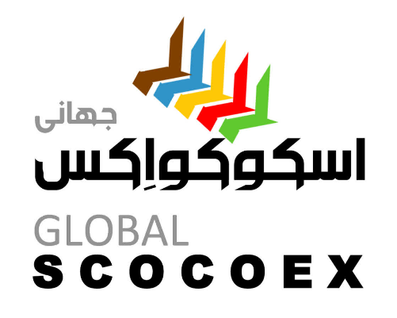

The SCOCOEX Logo
The SCOCOEX logo is a highly meaningful, thoughtfully designed, and visually compelling symbol that effectively reflects the organization's global vision and identity.
Its use of five distinct colors to represent the world's five continents is both symbolic and impactful, clearly communicating the event's international scope and commitment to global cooperation.
Another distinctive element of the logo is the representation of executive leadership seats ascending in flight, symbolizing progress toward excellence, collaboration, strategic alignment, and collective advancement. This visual metaphor reinforces the idea of visionary leadership working together to shape the future of international economic cooperation.
From both a conceptual and visual perspective, the logo successfully conveys the themes of movement, growth, innovation, and global partnership, making it a strong and appropriate identity for an international platform such as SCOCOEX Global Week.
Its design strengthens the credibility and distinctiveness of the SCOCOEX brand while communicating its mission to unite people, institutions, and nations in pursuit of sustainable economic development and shared prosperity.

Proposed Taglines for SCOCOEX Global Week
- SCOCOEX — A New Vision for Global Events
- Intelligence in Purposeful Global Networking
- Mapping the Future of Global Trade
- Economic Integration for a Sustainable Future
- The Next Generation of Global Events
- Charting the Course of Global Commerce

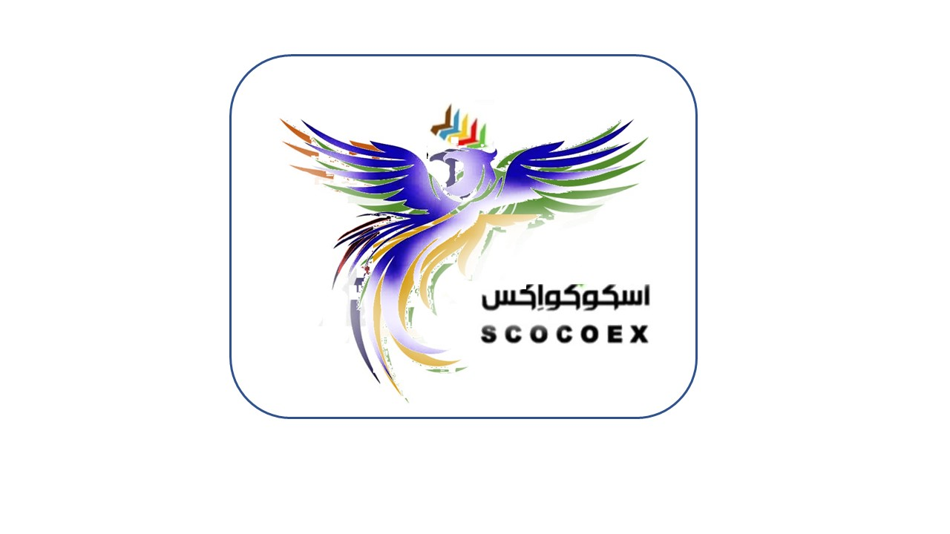

The SCOCOEX Symbol

The Colors and Spirit of the Phoenix
The Phoenix, with wings composed of the five colors representing the world's five continents, serves as the official symbol of SCOCOEX. It embodies the values of:
- Rebirth
- Rising above challenges
- Unity among nations and cultures
The Phoenix reflects the vision of renewal, resilience, and collective progress, symbolizing humanity's ability to transform challenges into opportunities through cooperation and innovation.
Every member of the SCOCOEX community is considered part of this shared story—a story of renewal, hope, enlightenment, and global collaboration.
Within the SCOCOEX philosophy, the Phoenix represents the pursuit of a peaceful global economy powered by knowledge, technology, and sustainable development, where international partnership becomes the driving force for a more prosperous future.

Host Nation Symbolism: Iran, Oman, and Uzbekistan
In selecting a symbolic identity for the host nations of SCOCOEX Global Week, careful consideration was given to finding an emblem that reflects strength, progress, peace, wisdom, and international cooperation.
Various birds traditionally associated with power and speed were evaluated. The falcon, while widely recognized as a symbol of strength, vision, and agility, was ultimately considered unsuitable for an event centered on the Economy of Peace, as it is inherently a bird of prey. Pairing the falcon with the dove, a universal symbol of peace and harmony, would create a conceptual contradiction—particularly for an international platform such as SCOCOEX, whose mission is founded on cooperation, sustainable development, and intelligent global partnership.
For this reason, the organizing committee sought a symbol that embodies both dignity and strength while conveying peace, wisdom, unity, and collaboration, without conflicting meanings.
Several alternatives were thoroughly evaluated for their cultural neutrality and alignment with the values of SCOCOEX:

1. Phoenix — The Preferred Symbol
The Phoenix emerged as the strongest and most appropriate choice.
It symbolizes:
- Rebirth and renewal
- Innovation and transformation
- Civilizational progress
- Hope and resilience
As a universally recognized mythological symbol with no negative connotations, the Phoenix perfectly reflects the knowledge-driven, technology-oriented, and globally inclusive identity of SCOCOEX.

2. Gazelle
The Gazelle represents:
- Grace and elegance
- Speed and agility
- Peaceful coexistence
- Harmony with nature
Its non-aggressive character aligns well with the principles of sustainable development and a dynamic global economy.

3. White Horse
The White Horse symbolizes:
- Honor and integrity
- Cooperation and partnership
- Nobility and leadership
- Peace through strength
Respected across many cultures, it represents a distinguished and timeless symbol suitable for an international event of high stature.

4. White Crane / Crowned Crane
The White Crane is internationally associated with:
- Peace and balance
- Long-distance connection and migration
- Unity among nations
- Cross-cultural cooperation
Its global symbolism makes it particularly appropriate for fostering intercontinental collaboration.

5. Osprey
The Osprey possesses many of the qualities associated with the falcon—strength, precision, exceptional vision, and leadership—without carrying the same symbolic contradiction. It represents:
- Strategic vision
- Precision
- Aspirational leadership
- Strength without aggression

Final Selection
After comprehensive evaluation by the Founding Board and the Policy Council, the Phoenix was unanimously selected as the official symbolic figure of SCOCOEX.
Depicted ascending in flight with wings composed of the five colors representing the world's five continents, the Phoenix embodies the organization's vision of renewal, global unity, peaceful economic development, innovation, and shared prosperity.
This design was formally endorsed as the symbolic identity of SCOCOEX Global Week, reflecting its mission to build a future founded on collaboration, knowledge, and sustainable international development.

The Spiritual and Aesthetic Identity of SCOCOEX

"SCOCOEX – The Phoenix of Peace and Prosperity Across Five Continents"

"SCOCOEX – The Phoenix of Global Peace, Innovation, and Prosperity"
"SCOCOEX – The Phoenix of Global Peace, Innovation, and Prosperity"

The SCOCOEX–Phoenix Identity
The combination of SCOCOEX and the Phoenix creates a powerful, timeless, and universally meaningful identity with no conceptual contradictions. As a mythical symbol, the Phoenix represents the ideal visual and philosophical emblem for the SCOCOEX brand, conveying renewal, unity, and global progress.

Why the Phoenix is the Ideal Symbol for SCOCOEX

1. A Symbol of Renewal and Transformation
SCOCOEX is a global platform dedicated to knowledge, technology, and international economic cooperation. The Phoenix perfectly reflects this mission through its universal symbolism of:
- Rebirth
- Rising above challenges
- Innovation and transformation
- The beginning of a new era of prosperity
These values align directly with the vision of SCOCOEX—to help nations, organizations, and businesses advance to higher levels of cooperation and sustainable development.

2. A Symbol of Unity Without Contradiction
Unlike symbols that may convey opposing meanings, the Phoenix is inherently unifying. It represents hope, resilience, and collective progress rather than conflict or competition.
For example, while the falcon symbolizes power and the dove symbolizes peace, combining them creates a conceptual inconsistency. The Phoenix, by contrast, naturally embodies both strength and peace within a single harmonious image.

3. A Symbol of the Five Continents
The Phoenix can be artistically designed with five prominent feathers or wings, each representing one of the world's five continents.
This creates a seamless connection between the symbolic identity of the Phoenix and the existing visual language of the SCOCOEX logo, reinforcing the organization's commitment to global inclusiveness and cooperation.

4. A Distinctive Global Brand Identity
The world's leading international organizations are recognized by memorable visual symbols:
- WEF — Geometric visual identity
- World Expo — Abstract symbolic designs
- SCOCOEX — The Phoenix as a timeless emblem of global cooperation
The Phoenix provides SCOCOEX with a distinctive and memorable identity capable of becoming an internationally recognized symbol.

5. Peace and Strength Without Conflict
The Phoenix embodies both dignity and strength while remaining entirely free of aggressive symbolism.
It represents a harmonious combination of:
- Peace
- Respect
- Visionary ambition
- Sustainable growth
- Collective prosperity

The Official Legend of SCOCOEX
The story of SCOCOEX and the Phoenix begins with a global need for dialogue, cooperation, and shared progress.
At a time when the world faced increasing economic challenges and divisive competition, SCOCOEX emerged like a Phoenix—rising from the ashes of adversity to inspire a new era of collaboration, innovation, and peace.
The Phoenix of SCOCOEX is not a bird of fire.
It is a symbol of knowledge, unity, opportunity, and human achievement.
Its five golden feathers connect the world's five continents, representing the bonds that unite nations, cultures, and economies.
The Phoenix of SCOCOEX carries a simple yet powerful message:
Every partnership is a new beginning. Every dialogue is a higher flight.

Official Logo Concept Guide

1. Overall Design
A minimalist, contemporary, and elegant Phoenix with wings extended upward, symbolizing:
- Growth
- Progress
- Visionary leadership
- Future-oriented development
Each wing incorporates five prominent feathers or flowing lines, representing the five continents.

2. Color Palette
The logo adopts five signature colors consistent with the SCOCOEX identity:
- Blue — Peace, knowledge, and trust
- Golden Yellow — Prosperity, excellence, and the global economy
- Green — Sustainability and balanced development
- Red — Energy, innovation, and transformation
- Purple — Wisdom, leadership, and strategic vision
Together, these colors reflect the diversity of humanity united through a shared vision of sustainable global prosperity.

3. Typography

Persian
- Vazir
- IranSans
- Dana
- Saman Bold

English
- Montserrat
- Gilroy
These typefaces provide a clean, modern, and internationally recognizable visual identity while maintaining readability across digital and printed media.

4. Logo Applications
The SCOCOEX logo is designed for multiple official applications, including:
- Luxury gold edition for official documents, certificates, awards, and diplomatic materials
- Full-color version for brochures, publications, websites, exhibitions, and promotional materials
- Single-color version for metal engraving, official badges, lapel pins, trophies, and premium merchandise
This flexible identity system ensures consistency across all communications while reinforcing SCOCOEX as a globally recognizable symbol of peace, innovation, collaboration, and sustainable prosperity.

The Official SCOCOEX Message Featuring the Phoenix
The following message may be used in the opening ceremony, introductory video, or the first pages of the official brochure:
"SCOCOEX is the global Phoenix of collaboration—where nations, businesses, and institutions come together to transform challenges into opportunities. Here begins a new journey of flight, connecting the five continents through peace, innovation, and shared prosperity."

The Phoenix Symbol in Global Brands
The Phoenix has been adopted by a number of well-known organizations and brands around the world. Although its use is relatively uncommon—owing to its strong symbolic significance—it is widely recognized as a symbol of renewal, resilience, transformation, and enduring success.

1. Porsche (Indirect Association)
The Porsche emblem contains a heraldic bird that is sometimes informally associated with the Phoenix. However, this interpretation is not official; the logo primarily features the coat of arms of Stuttgart, including its famous rearing horse.

2. Phoenix Technologies
An American technology company specializing in BIOS firmware and computer hardware.
The company uses the Phoenix directly as its corporate symbol, representing:
- System renewal
- Technological resilience
- Continuous innovation

3. Phoenix Group (United Kingdom)
One of the United Kingdom's largest long-term savings and retirement services companies.
Its golden Phoenix logo symbolizes:
- Financial security
- Longevity
- Renewal and sustainable growth

4. AirAsia X (Former Branding Campaigns)
During selected rebranding initiatives, AirAsia X incorporated the concept of the "Rising Phoenix" as a metaphor for renewal and future growth.

5. Abercrombie & Kent (Historical Visual Identity)
Some earlier versions of the company's visual identity incorporated Phoenix-inspired imagery to represent exploration, renewal, and exceptional travel experiences.

6. Phoenix Beer (Mauritius)
One of Mauritius' best-known beverage brands.
Its primary logo features a Phoenix with outstretched wings, symbolizing strength, heritage, and resilience.

7. Educational, Cultural, and Sports Organizations
The Phoenix has also inspired the identities of various institutions and organizations, including:
- University of Phoenix
- Phoenix Suns (NBA)
- Various educational and cultural organizations that use Phoenix-inspired imagery to symbolize aspiration, perseverance, and achievement.

8. Luxury Jewelry and Fashion Collections
Several luxury houses—including Boucheron, Cartier, and Buccellati—have occasionally introduced limited-edition collections inspired by the Phoenix as a symbol of rebirth and timeless elegance. While the Phoenix has appeared as a creative motif in these collections, it is not part of their official corporate logos.

The Significance of the Phoenix for SCOCOEX
Very few international organizations or global brands have adopted the Phoenix as their permanent official symbol. This presents a unique opportunity for SCOCOEX.
By selecting the Phoenix as its official emblem, SCOCOEX can establish a distinctive, enduring, and globally recognizable identity that is both memorable and highly differentiated.
The SCOCOEX Phoenix identity is built upon six core elements:
- Symbolic Philosophy
- The Foundational Legend
- Official Slogans
- Logo Design Concept
- Brand Application Guidelines
- Official Message for Brochures and the Website

1. The Phoenix Philosophy of SCOCOEX
Within the philosophy of SCOCOEX, the Phoenix embodies three fundamental principles.

Rebirth Through Transformation
Every nation, company, institution, or organization that joins SCOCOEX is encouraged to transform challenges, limitations, and uncertainty into new opportunities for sustainable growth and international cooperation.
The Phoenix represents resilience, renewal, and the continual pursuit of progress.

Five Continents, One Flight
The wings of the SCOCOEX Phoenix are envisioned with five principal feathers, each representing one of the world's continents:
- Africa
- Asia
- Europe
- The Americas
- Oceania
Although each feather symbolizes a distinct region of the world, together they form one unified bird, expressing the idea that global cooperation transcends borders while respecting diversity.

The Flame of Knowledge, Peace, and Prosperity
SCOCOEX is founded upon knowledge, innovation, economic collaboration, and peace.
Likewise, the Phoenix symbolizes a rare balance between strength and harmony.
It is neither an aggressive predator nor a symbol of weakness; instead, it represents dignity, wisdom, resilience, and enlightened leadership.

2. The Official Legend of SCOCOEX and the Phoenix
(For use in brochures, opening ceremonies, promotional films, and the official website.)
At a time when the world faced increasing competition, economic uncertainty, and widening cultural divides, voices from across the five continents called for greater dialogue, cooperation, and a shared vision for the future.
From this global aspiration, SCOCOEX was born.
With it rose a Phoenix—not from flames of conflict, but from the quiet light of knowledge, wisdom, and peace.
This Phoenix soars to bring nations closer together, unite businesses and institutions, and inspire a future in which all can prosper through collaboration.
The Phoenix of SCOCOEX carries a timeless message:
"Every challenge holds the promise of renewal—provided we spread our wings together."

3. Official Slogans

Persian
- SCOCOEX – The Phoenix of Peace and Global Prosperity
- Five Continents, One Flight
- From Challenge to Excellence
- Rise Together. Fly Higher Together.

English
- SCOCOEX — The Phoenix of Global Prosperity
- Five Continents, One Flight
- Rising Together
- From Challenges to Greatness

4. Official Logo Concept Blueprint

Overall Design
The official emblem features a minimalist, elegant, and contemporary Phoenix with wings fully extended upward, symbolizing:
- Vision
- Growth
- Renewal
- International leadership
- A shared future
The body of the Phoenix is rendered in a refined golden form, representing excellence, prestige, and global significance.
Each wing incorporates five distinctive feathers, symbolizing the world's five continents united within a single vision.

Color Palette
The visual identity is built around a carefully balanced palette:
- Royal Gold — Prosperity, excellence, and international stature
- Blue — Knowledge, trust, and peace
- Red — Energy, innovation, and transformation
- Green — Sustainability, growth, and harmony
- Purple — Wisdom, strategic leadership, and depth

Design Character
The overall visual language should communicate sophistication and credibility while remaining timeless and internationally relevant.
The logo should evoke the design standards associated with globally recognized institutions such as the World Economic Forum (WEF) and World Expo, presenting an identity that is:
- Elegant rather than ornate
- Contemporary rather than trendy
- Authoritative rather than aggressive
- Inspirational rather than symbolic of conflict
- Suitable for international registration and long-term institutional use
This approach positions the Phoenix as the enduring visual embodiment of SCOCOEX's mission to advance global cooperation, innovation, sustainable prosperity, and peace.

5. Brand Usage Guide
To ensure consistency and preserve the integrity of the SCOCOEX visual identity, the Phoenix symbol should be applied according to the following guidelines:

1. Classic Gold Edition
Reserved for high-level official applications, including:
- International agreements and contracts
- Official correspondence between heads of state and senior government officials
- Diplomatic documents
- VIP credentials
- Executive certificates
- Official lapel pins and insignia for distinguished guests

2. Full-Color Edition
Intended for communication and promotional materials, including:
- Corporate brochures
- Official website
- Opening ceremony videos
- Exhibition booths
- Event signage
- Venue entrances
- Digital presentations
- Marketing and promotional campaigns

3. Monochrome Edition
Designed for applications where a simplified version is required, such as:
- Laser engraving on metal
- Security documents
- Cost-efficient printing
- Gift packaging and ribbons
- Corporate merchandise
- Official seals and embossed materials

6. The Official SCOCOEX Phoenix Manifesto
"SCOCOEX is the Phoenix of innovation and global collaboration—a place where nations, institutions, and businesses rise from the ashes of challenges to soar together toward peace, knowledge, and shared prosperity. We are here to help shape a better world—through every dialogue, every partnership, and every new flight toward the future."

Official Typography Guidelines
Selecting the appropriate typography is essential to expressing the prestige, professionalism, and international character of SCOCOEX Global Week.

Recommended Persian Typefaces

1. IRAN Sans X — Primary Recommendation
The preferred Persian typeface for the SCOCOEX brand.
Key characteristics:
- Contemporary and highly legible
- Professional and authoritative
- Widely used by major organizations and international events
- Conveys innovation, technology, and institutional credibility

2. Dana
A premium Persian typeface with an elegant visual presence.
Best suited for:
- Executive publications
- Luxury printed materials
- Large titles and ceremonial documents

3. Samim or Vazir
Recommended for:
- Long-form publications
- Reports
- Brochures
- General reading materials
These fonts offer excellent readability while maintaining a clean and formal appearance.

Recommended English Typefaces

1. Montserrat — Primary Recommendation
Montserrat is the preferred English typeface for SCOCOEX.
Its advantages include:
- Modern international appearance
- Exceptional readability
- Strong compatibility with IRAN Sans X and Dana
- Widely used in global economic, technology, and diplomatic events

2. Gotham
A premium corporate typeface frequently associated with international institutions.
It communicates:
- Authority
- Trust
- Prestige
- Executive professionalism
Particularly suitable for official titles and large-format communications.

3. Helvetica Neue
A timeless and highly legible typeface ideal for extensive body text, official publications, and professional documentation.

Recommended Typography System

Persian
- Headings: IRAN Sans X Bold
- Body Text: IRAN Sans X Regular

English
- Headings: Montserrat SemiBold
- Body Text: Montserrat Regular

Recommended Brand Typography
The following combination is recommended as the official typography system for SCOCOEX Global Week:
Persian
- IRAN Sans X Bold (Headings)
- IRAN Sans X Regular (Body Text)
English
- Montserrat SemiBold (Headings)
- Montserrat Regular (Body Text)
This pairing creates a modern, sophisticated, and internationally recognizable visual identity that effectively reflects the prestige and ambition of the SCOCOEX brand. It is well suited for a global event comparable in stature to leading international forums such as the World Economic Forum (WEF) and World Expo, while delivering excellent readability and consistency across print, digital media, presentations, posters, and official publications.
SCOCOEX Mascot
The Iranian cheetah (especially in memory of Pirouz) is one of the best choices for the official SCOCOEX mascot—and, in terms of identity, culture, and global message, it carries extraordinary symbolic power.
Why is the "Iranian Cheetah – Pirouz" an excellent mascot for SCOCOEX?
1) A Global Message of Nature Conservation and Hope
The Asiatic cheetah symbolizes a universal truth: it reminds the world of the value of environmental conservation and the importance of saving endangered species, while conveying a message of hope and rebirth.
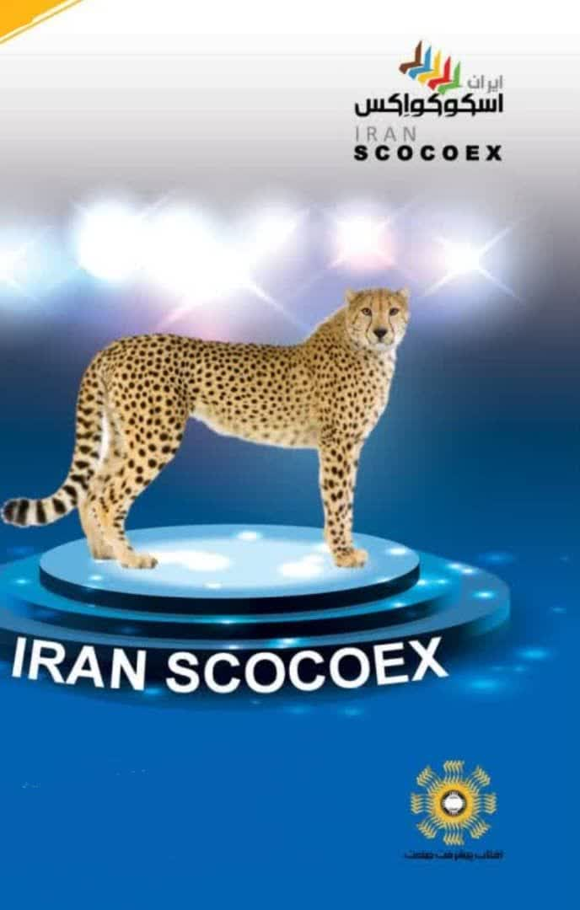

The name "Pirouz" precisely conveys the sense of overcoming challenges and surviving—just like the mission of SCOCOEX, which seeks peace, cooperation, and development.
2) The Cheetah and the Name "Pirouz" as a Powerful Branding Tool for the International SCOCOEX Event
Many major international events have adopted a national animal as their official mascot:
Qatar – La’eeb, Japan – Mira ito wa, China – Panda Bing Dwen Dwen, the United States – the Eagle for the World Cup, Canada – the Moose, and Mexico – the Tiger.
The Iranian cheetah can achieve a similar status, representing speed, intelligence, dignity, authenticity, and a forward-looking vision.
3) Connection with the Five Continents and the Five SCOCOEX Colors
The SCOCOEX cheetah can be designed using the event's five symbolic colors:
the mane or body stripes, a necklace or emblem on the chest, and the tail in five colors. This would complete the event's global identity.
4) Public Affection and the Popularity of the Name "Pirouz"
For Iranians, the cheetah Pirouz carries a strong emotional, national, and honorable significance.
When this emotional connection is transferred to the SCOCOEX brand, it will result in:
- Greater popularity of the mascot
- Strong merchandise sales
- A powerful emotional identity for the event
✔ Initial character design (Character Design) or the official cartoon version
✔ Official character story and the identity protocol booklet for the cheetah mascot
When selecting an official symbol or mascot for countries such as Oman and Uzbekistan, three principles should be observed:
- Rootedness in the country's culture and natural environment
- A global message appropriate for an event like SCOCOEX
- Appeal and suitability for mascot design, logos, and merchandise
Proposed SCOCOEX Symbol for Oman

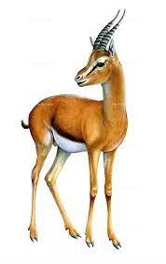

Oman is a country with a rich maritime heritage, a tradition of peace, historical grandeur, and a unique natural environment.
Symbols of Oman:
1) Arabian Oryx (Arabian Oryx / White Oryx) is the national symbol of Oman and was successfully rescued from extinction.
Characteristics:
- A symbol of dignity, agility, peace, and resilience
- Strongly connected to the desert and Arabian nature
- Highly suitable for mascot design
Its story: Oman was the first country in the world to successfully reintroduce the Arabian oryx into the wild.
This is an outstanding message for SCOCOEX: restoration, hope, sustainability, and global cooperation.
2) Green Sea Turtle
Oman is home to one of the world's most important nesting sites for sea turtles.
Symbolizes:
- Environmental conservation
- Long-distance journeys
- Oman's maritime heritage
It is especially suitable for the environmental section of SCOCOEX.
3) Omani Falcon (Saker Falcon / Trained Falcon)
A symbol of grandeur, courage, and royal heritage, as well as one of the region's traditional sports.
It is particularly appropriate for the VIP section and protocols for high-ranking officials.
Proposed Symbol for SCOCOEX in Uzbekistan


Uzbekistan has deep civilizational roots: the Silk Road, Registan, the Turkestan tiger, the Akhal-Teke horse, and Timurid artistic traditions. The best symbolic options are:
1) Turkestan Tiger – The Best Symbolic Choice
Although extinct, it remains deeply rooted in the nation's culture and legends.
The Turkestan tiger symbolizes:
- Grandeur
- Cultural and historical strength
- The revival of life
- The return of hope
It is highly suitable for storytelling and mascot design.
This symbol conveys an epic yet peaceful energy, much like the phoenix.
2) Akhal-Teke Horse
One of the world's most beautiful and rare horse breeds, with strong cultural ties throughout Central Asia.
It symbolizes:
- Speed
- Nobility
- Civilizational grandeur
- Travel and Silk Road trade
It is well suited to international events because it represents "progress and the connection of nations."
3) Samarkand Peacock
Frequently featured in Timurid art and the architecture of Uzbekistan.
It symbolizes:
- Beauty
- Art
- Cultural magnificence
It is especially suitable for attracting cultural and artistic tourism and is an excellent symbol for the cultural section of SCOCOEX.
Final Summary
Proposed Official Symbol for Oman:
The Arabian Oryx (Oryx) — noble, peaceful, ideal for a mascot, and a strong identity-building symbol.
Proposed Official Symbol for Uzbekistan:
The Turkestan Tiger — magnificent, legendary, and highly suitable as both a cultural symbol and an official mascot.
For SCOCOEX, as a knowledge-driven, technology-oriented, and peace-building event, the selected animal or bird must be aligned with the event's mission both spiritually and conceptually.
Therefore, choosing these symbols was an extremely challenging process, and extensive research was conducted before reaching the final selection.
Proposed Symbol for SCOCOEX in Bulgaria
Considering Bulgaria's cultural identity, history, and civilization, there are several excellent options for selecting a national symbol.
1. Bulgarian Lion – The Best Choice
Cultural Significance:
The lion is Bulgaria's most important national symbol.
It has appeared in royal coats of arms for more than 700 years and later became part of the official emblem of the Republic of Bulgaria.
It symbolizes:
- Courage
- Authority
- Independence
- Leadership
- National identity
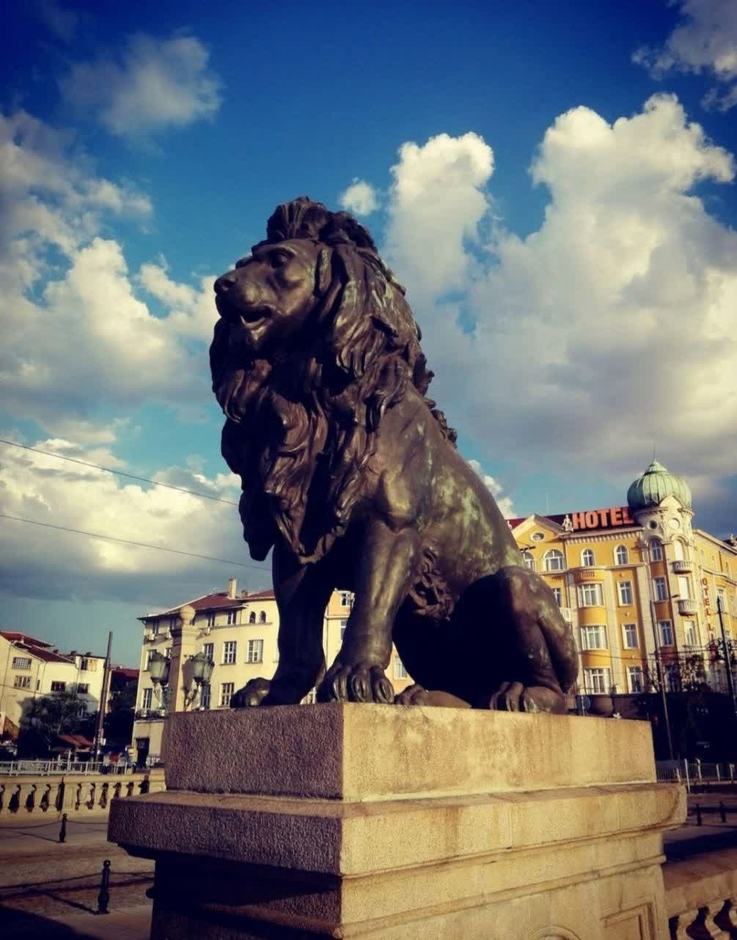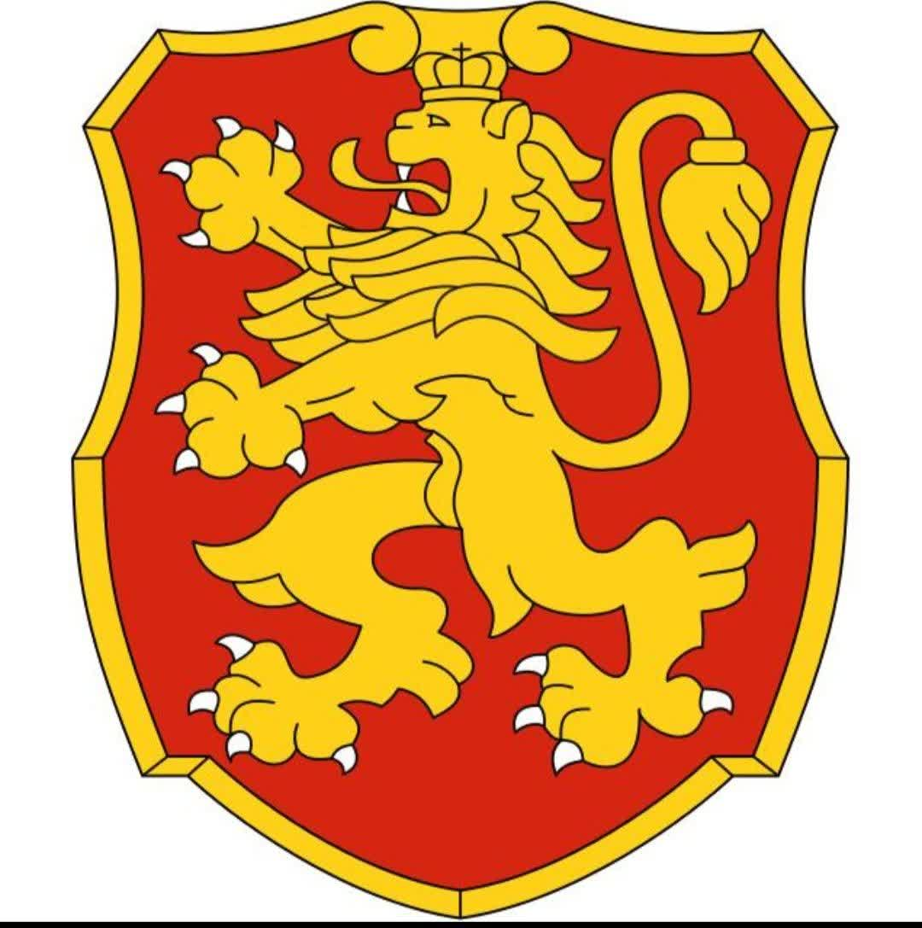
Connection with Our Project
Together, these four symbols create a perfectly balanced identity:
- Iran (Phoenix): Rebirth
- Oman (Arabian Oryx): Peace and Grace
- Uzbekistan (Tiger): Strength and Courage
- Bulgaria (Lion): Leadership and Authority
2. Balkan Falcon (Falcon)
Bulgaria is one of the important habitats of falcons in Europe.
Symbolism: Foresight, speed, and intelligence.
It is also a suitable symbol for strengthening the connection between East and West in the context of an international economic summit.
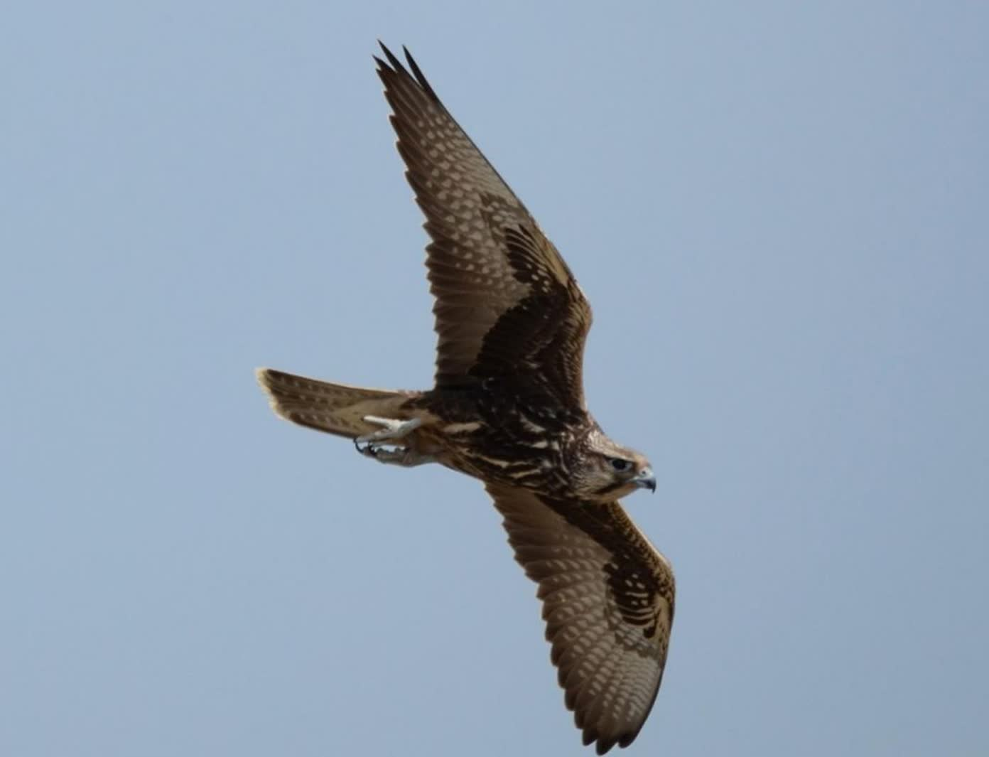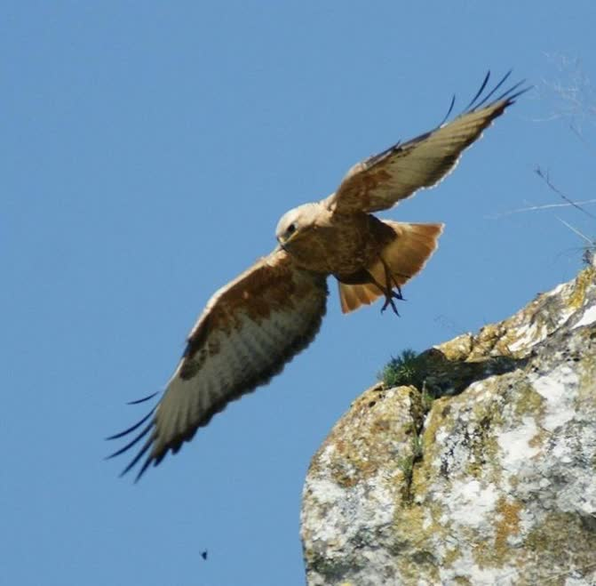
3. Bulgarian Rose
Bulgaria is the world's largest producer of rose oil.
Symbolism: Beauty, peace, and culture.
It is an excellent choice for representing soft diplomacy at a summit focused more on culture and tourism. However, for a trade-oriented event, it may not convey the same level of strength and authority as the lion symbol.
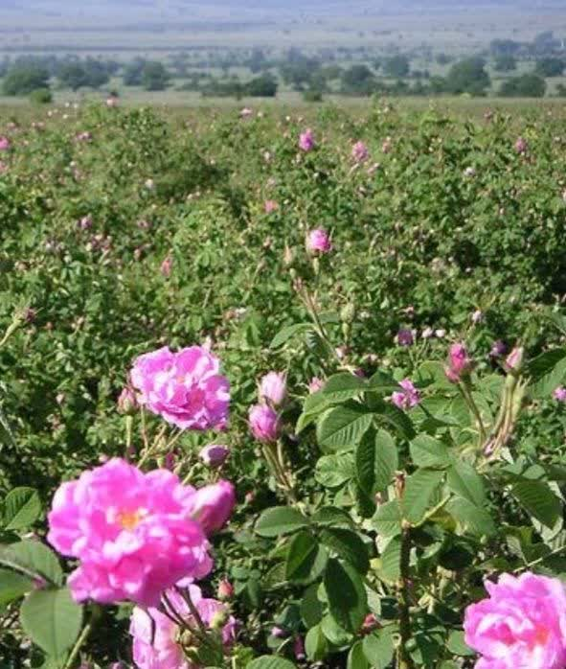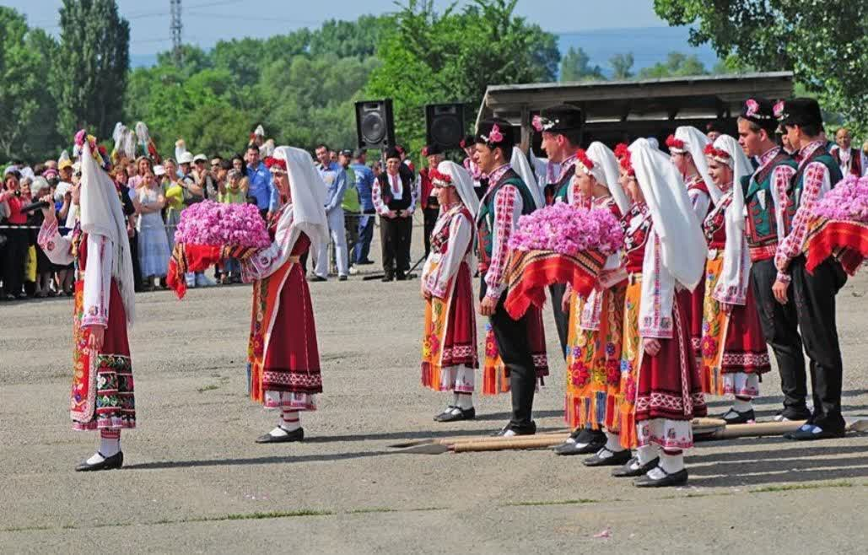
4. Thracian Horse
Bulgaria is the heir to the ancient Thracian civilization.
In Thracian culture, the horse symbolizes movement, civilization, progress, and victory.
The Madara Rider, one of Bulgaria's most important historical monuments and a UNESCO World Heritage Site, further reinforces this symbolism.
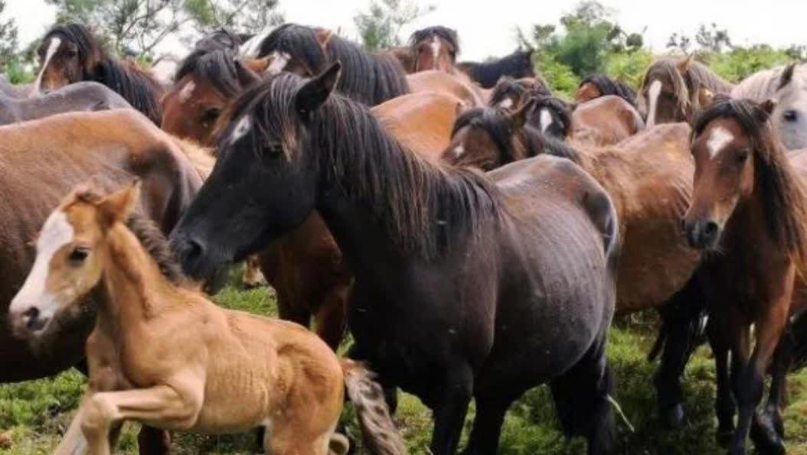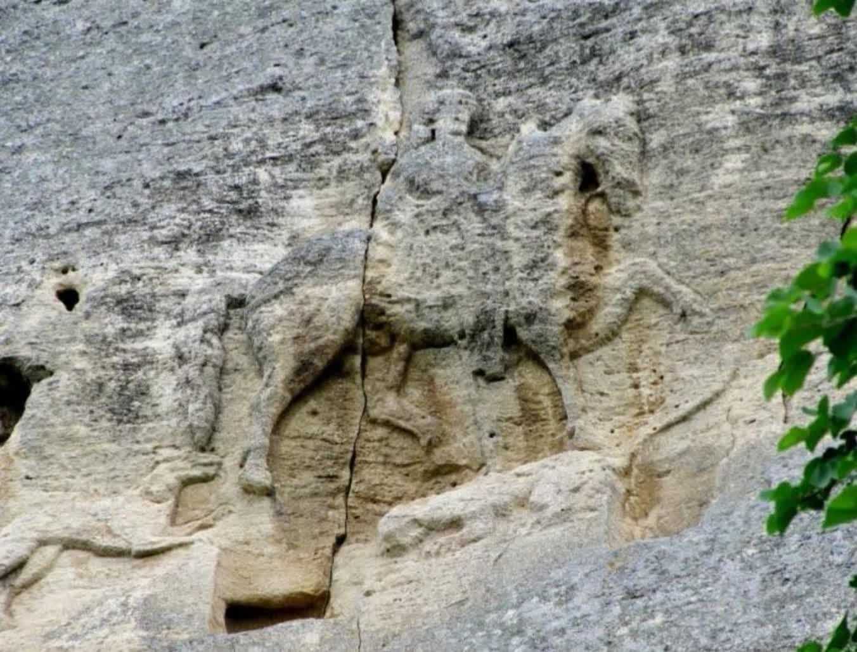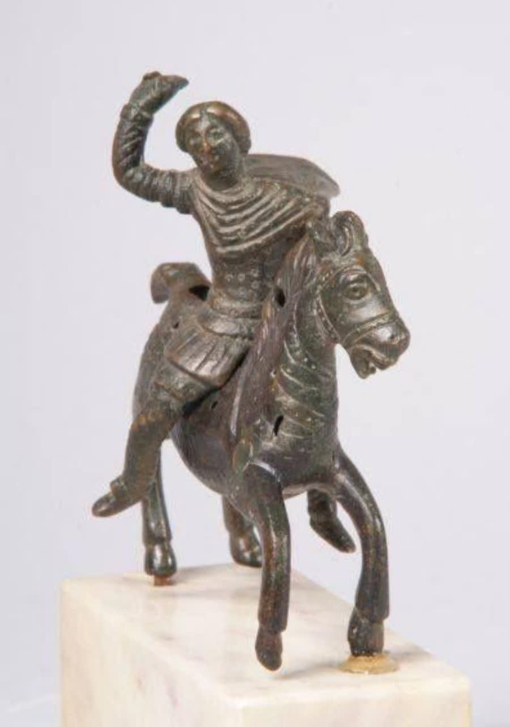
5. Golden Eagle
Symbolism: Authority, freedom, and vision for the future.
From a long-term perspective and in terms of international branding, it is a strong option. However, it does not represent Bulgaria's national identity as effectively as the lion.
Final Recommendation:
If each of the four countries is to have its own symbolic animal, the following combination is highly harmonious and meaningful:
Country | Symbol | Meaning
Iran | Phoenix | Rebirth, hope, civilization
Oman | Arabian Oryx | Peace, dignity, sustainability
Uzbekistan | Tiger | Strength, courage, progress
Bulgaria | Lion | Leadership, authority, independence
In my opinion, the Bulgarian Lion is the best choice because it is both the country's official and widely recognized national symbol, has deep cultural and historical roots, and, alongside the Phoenix, Arabian Oryx, and Tiger, creates a powerful symbolic identity for the SCOCOEX brand.
Next, we considered five other highly suitable and professional alternatives to the Phoenix, which we present below along with the rationale for each:

1. Falcon – The Best Alternative for SCOCOEX
Symbolism: Vision, speed, and decisive leadership.
The falcon is a beloved and iconic symbol across many Middle Eastern countries, especially Oman, the United Arab Emirates, Qatar, and Saudi Arabia.
It is an excellent choice for an international event because it conveys leadership, foresight, and ambition, while aligning perfectly with the themes of innovation, technology, and the global economy.
Meaning for SCOCOEX:
"Like a falcon, SCOCOEX connects the world through a far-reaching vision for peace and progress."

2. White Dove – The Symbol of Peace
An ideal symbol for SCOCOEX's global message.
It is the universally recognized emblem of peace and represents the unity of nations, harmony, and global cooperation.
If SCOCOEX is positioned primarily around diplomacy, solidarity, and dialogue, the White Dove is the strongest choice.

3. Eagle/Hawk – A Symbol of Strength and Prestige
Represents authority, elevation, focus, and global leadership.
It is well suited to major international economic events such as WEF and Expo.
It is also highly attractive to major sponsors because it projects the image of a powerful, prestigious, and influential event.

4. Gazelle – A Symbol of Agility and Elegance
An excellent symbol for innovation, rapid economic growth, youth-driven development, and startup ecosystems.
It is also native to many of the target countries, including Oman, Iran, and the United Arab Emirates.
If SCOCOEX seeks to project an image that is graceful, dynamic, and future-oriented, the Gazelle is an outstanding choice.

5. Arabian Horse – A Symbol of Prestige and Heritage
If the objective is to establish the event as luxurious, prestigious, and distinguished—similar to WEF or Expo—the Arabian Horse is an ideal symbol.
It represents strength, authenticity, nobility, speed, and endurance, and enjoys broad cultural significance and acceptance throughout the host region.
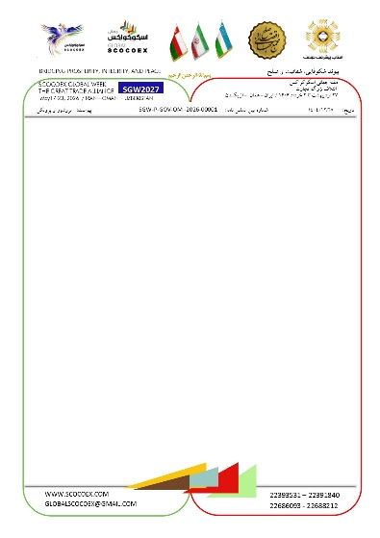
Professional Analysis of the SCOCOEX Letterhead
The SCOCOEX letterhead is professional, meaningful, and strongly rooted in its visual identity.
From the perspectives of international branding, diplomacy, and corporate identity design:

1. Triangles as Converging Flags — Excellent
The combination of the five colors and the flag-like arrangement of the triangles is fully aligned with the philosophy of SCOCOEX:
- Movement toward unity
- Representation of the five continents
- Rhythm and forward momentum
From a visual psychology perspective, this design conveys dynamism, continuity, and the convergence of collective strengths.
It is highly appropriate for a global event.

2. The Use of Fine Lines in the Colors of the Iranian Flag — A Highly Intelligent Design Choice
This approach offers three key advantages:
✔ It expresses national identity without exaggeration.
The colors are neither overly prominent nor hidden; they are presented with a balanced and appropriate level of visibility.
✔ It appears highly professional in international correspondence.
The colors of Iran are incorporated subtly, while the overall letterhead maintains a neutral and global appearance.
✔ It symbolizes the connection between Iran and the five continents.
This creates an elegant and understated message.

3. Spiritual, Literary, and International Messaging
The text featured on the letterhead carries spiritual depth, is inspirational, and is understandable across different cultures.
Through its messaging, SCOCOEX rises above political boundaries and becomes a global humanitarian movement.
At the level of major international events, such messaging enhances credibility and creates a distinctive identity.

4. Persian–English Harmony
The bilingual layout is well balanced for both domestic and international audiences.
It conveys the visual identity and professionalism associated with international organizations such as the UN, WEF, and Expo.

5. Graphic Signature at the Bottom of the Page
The curved elements in the corners soften the formal administrative appearance.
They visually connect with the curves of the logo and reinforce the concept of convergence.
The combination of green and red at the bottom establishes a unique and recognizable visual identity.

Final Assessment of the SCOCOEX Letterhead
✔ Meets international standards.
✔ Possesses a strong and cohesive visual identity.
✔ Communicates spiritual values without exaggeration.
✔ Is entirely appropriate for correspondence with presidents, ministers, and international organizations.
✔ From a branding perspective, it is a simple yet powerful masterpiece.
Regarding the SCOCOEX Letterhead, Logo, and Symbol
The SCOCOEX letterhead is truly professional, meaningful, and rich in identity. From the perspective of international branding, diplomacy, and corporate identity design:
Professional Analysis of the SCOCOEX Letterhead
1) Triangles as Converging Flags — Excellent
The combination of the five colors and the flag-like triangular forms is fully aligned with the philosophy of SCOCOEX:
- Movement toward unity
- Representation of the five continents
- Rhythm and forward momentum
From the perspective of visual psychology, this design conveys dynamism, flow, and the convergence of collective forces.
It is highly appropriate for an international event.
2) The Use of Thin Lines in the Colors of the Iranian Flag — A Highly Intelligent Design Choice
This approach offers three advantages:
✔ It presents the national identity without exaggeration.
It is neither overly prominent to appear promotional nor too subtle to be unnoticed. It is applied with an ideal level of balance.
✔ It appears highly professional in international correspondence.
The colors of Iran are incorporated in a refined manner, while the overall letterhead remains neutral and global in character.
✔ It symbolizes the connection between Iran and the five continents.
This creates a subtle yet elegant underlying message.
3) Spiritual, Literary, and International Messaging
The text included on the letterhead:
- Possesses spiritual depth
- Is inspiring and understandable across all cultures
This message transforms SCOCOEX beyond politics into a global humanitarian movement.
At the level of international events, such messaging creates credibility and distinction.
4) Persian–English Harmony
The bilingual arrangement of information serves both:
- Domestic audiences
- International audiences
It is perfectly balanced and evokes the visual identity of international organizations such as UN, WEF, and EXPO.
5) Graphic Signature at the Bottom of the Page
The curved elements in the corners:
- Soften the rigidity of a formal administrative document
- Relate to the curvature of the logo and the concept of convergence
- The combination of the green and red graphic elements at the bottom creates a unique visual identity.
Final Assessment of the SCOCOEX Letterhead
✔ Meets international standards
✔ Possesses a strong and cohesive visual identity
✔ Communicates spiritual messages without exaggeration
✔ Is fully appropriate for correspondence with Presidents, Ministers, and international organizations
✔ From a branding perspective, it is a simple yet powerful masterpiece.
Letter Signature Options:
Option 1
With faith in peace, development, and a future built on global cooperation.
Dr. Esmaeil Shoja
Founder and President of the SCOCOEX International Event
Chief Executive Officer, Aftab Pishraft Sanat Company
DBA Graduate

Option 2
With faith in peace, development, and a future built on global cooperation.
Dr. Esmaeil Shoja
Founder and President of the SCOCOEX International Event
Chief Executive Officer, Aftab Pishraft Sanat Company

Option 3
With faith in peace, development, and global cooperation.
Dr. Esmaeil Shoja
Founder and President of the SCOCOEX International Event
SCOCOEX Foundation
The Governance Structure of SCOCOEX
SCOCOEX FOUNDATION
The Pillar of Support, Development, and Innovation for SCOCOEX Global Week

Definition of the SCOCOEX Foundation
The SCOCOEX Foundation is an international non-governmental organization (NGO) whose mission is to support, develop, and sustain the projects, businesses, innovations, and cultural and sporting programs of SCOCOEX.
The Foundation serves as the pillar of stability, transparency, and credibility for SCOCOEX Global Week.

Key Objectives of the Foundation
- Support projects and startups.
- Establish investment networks and connect projects with financial resources.
- Promote education and research.
- Organize specialized courses, workshops, and academies.
- Support cultural and artistic initiatives.
- Enhance cultural nights, concerts, exhibitions, and artistic events.
- Strengthen sports and public engagement.
- Organize competitions, championships, and community activities.
- Foster international relations and diplomacy.
- Build bridges of cooperation among governments, international organizations, and the private sector.
- Monitor and evaluate the impact of projects and programs.
- Ensure alignment with the principles of peace, innovation, and sustainable development.

Mission of the SCOCOEX Foundation
Mission: To advance economic, technological, and cultural cooperation among diverse societies in pursuit of lasting peace and sustainable prosperity.
The Foundation's declared mission is "to improve international trade among nations by engaging business leaders, merchants, traders, policymakers, academics, and other communities in shaping economic development and global, international, regional, and industrial prosperity."
Beginning in its second year, the Foundation intends to be primarily financed through the membership of at least 5,000 leading companies, selected from among the top 20,000 companies across more than 200 target countries.
Funding for SCOCOEX during its first year will be provided through private investment from Iranian, Omani, and Uzbek partners, supplemented by the recruitment of strategic partners and sponsors. From the second year onward, financial sustainability will be supported through membership subscription fees and host country licensing rights.
Leadership and Governance of SCOCOEX
The Founder of SCOCOEX seeks to establish a model of global corporate governance to advance the Foundation, where values are regarded as equally important as rules.
Legitimacy, accountability, transparency, and coordinated action are the guiding principles of the Foundation.
The Foundation is led by its Founder and Executive President, Dr. Esmaeil Shoja, and is guided by a Board of Trustees composed of distinguished individuals who serve as custodians of its mission and values while overseeing its efforts to promote genuine global citizenship.
Aftab Pishraft Sanat Company, governed by its Board of Directors elected by the shareholders and chaired by Mrs. Maryam Danideh, serves as the executive entity responsible for organizing the SCOCOEX International Event. This structure ensures that all activities are conducted in alignment with the mission of SCOCOEX and that the company acts as its representative in external relations.
The Company bears collective executive responsibility for SCOCOEX and reports directly to the Board of Trustees.
The activities of the SCOCOEX Foundation are carried out under the leadership of its Founder.

Organizational Structure of the SCOCOEX Foundation

Board of Trustees
The Board of Trustees consists of business leaders, scientists, representatives of governments, and participating cities. It is composed of distinguished leaders from business, politics, academia, and civil society.
Members of the Board of Trustees are expected to perform their duties with complete impartiality and shall not represent or promote personal, professional, partisan, or political interests in carrying out their responsibilities.
Responsibilities:
- Establish strategic policies.
- Approve major projects and initiatives.
- Provide overall governance and oversight.

Executive Council
Responsible for the day-to-day management of the Foundation and coordination among its various divisions.
The Executive Council oversees the implementation of cultural, sports, educational, and operational programs.

Projects and Investment Division
- Evaluate projects and investment opportunities.
- Connect projects with investors and international strategic partners.

Research and Education Division
- Develop scientific and educational content.
- Organize workshops, training programs, and specialized academies.

Culture and Arts Division
- Manage cultural and artistic evenings.
- Organize concerts, exhibitions, and cultural events.

SCOCOEX Foundation Projects
- Establishing a global network of technology-driven projects and innovative businesses.
- Supporting smart cities and urban development projects.
- Developing arts and cultural programs on a global scale.
- Organizing international sports activities and competitions.

The Role of the Foundation within the Global SCOCOEX Network
- Supporting all businesses and projects within the SCOCOEX ecosystem.
- Establishing standards and ensuring transparency across all activities.
- Facilitating connections among stakeholders and the global investment network.
- Ensuring the social, economic, and cultural impact of projects and initiatives.

Benefits of the Foundation for Stakeholders
- Access to investment networks and strategic partners.
- Legal, financial, and managerial support for projects.
- International credibility and Foundation certification for projects and businesses.
- Opportunities to participate in exhibitions, cultural nights, and sports programs.
- Specialized consulting, mentoring, and training for teams and startups.

Vision of the SCOCOEX Foundation
The SCOCOEX Foundation serves as the strategic pillar of SCOCOEX Global Week, with the vision to:
- Create a sustainable ecosystem encompassing economic, cultural, sports, and technological development.
- Build connections between nations and investors to promote peaceful development.
- Expand a global network of innovative and high-impact projects and businesses.
Constitution of the SCOCOEX Foundation
(Official Edition – Designed for Long-Term Institutional Use)

Article 1 – Name, Nature, and Identity
SCOCOEX – Smart Cooperation for Economic Excellence
The SCOCOEX Foundation is an international organization dedicated to knowledge-based cooperation, technology-driven collaboration, and sustainable economic development.
The Foundation is an independent, non-political, non-governmental, and multi-continental institution.

Identity and Establishment of SCOCOEX
The identity of the SCOCOEX Foundation was conceived through an Iranian initiative. It was established and is permanently headquartered in Iran, while countries around the world may contribute to its growth and development.
As a private and non-governmental initiative, the SCOCOEX Foundation officially commenced its activities concurrently with the formal accession of the Islamic Republic of Iran to the Shanghai Cooperation Organization (SCO) during the 21st Summit of the Council of Heads of State, held in Dushanbe, Tajikistan, on 17 September 2021 (corresponding to 26 Shahrivar 1400 in the Iranian calendar). Its operational activities began in Tehran.
The permanent headquarters of SCOCOEX is located in Tehran, and the Foundation will establish regional offices across the five continents.
On 26 December 2025, coinciding with the celebration of the birth of Jesus Christ, authorization for organizing the Foundation's events was granted by the Government of the Islamic Republic of Iran in accordance with the laws of Iran, the host country for the inaugural year.
The permanent headquarters of SCOCOEX in Tehran will host representatives from both the public and private sectors serving as national strategic partners.

Article 2 – Mission
To establish a global cooperation network connecting governments, cities, companies, universities, and distinguished leaders in order to promote:
- Sustainable and ethical wealth creation.
- Technological advancement.
- Urban development.
- Social well-being.
- The strengthening of trade and sustainable economic growth.
- Peace and economic integration.

Article 3 – The 100-Year Vision of SCOCOEX (Through 2125)
To become:
- The world's leading reference for national and urban futures studies.
- The largest technology cooperation network across the five continents.
- The organizer of SCOCOEX Global Week.
- A globally recognized academy for developing the leaders of the future.

Article 4 – Core Values
- Global cooperation
- Innovation
- Transparency
- Sustainability
- Human-centered development
- Balanced development
- Respect for cultures
- Technology in the service of peace

Article 5 – Governing Bodies
- Board of Trustees
- Supreme Strategic Council at both the national level of host countries and the international level
- Global Secretariat
- Regional Offices across the five continents
- SCOCOEX International Academy
- Scientific and Technology Committee
- Smart Cities and Mayors Commission
- Finance and Investment Committee

Article 6 – Board of Trustees
The Board of Trustees is the highest governing authority of the Foundation.
- The Founder serves as the lifetime Chair of the Board of Trustees (currently aged 60).
- Establishes the Foundation's 10-year, 30-year, and 100-year strategic policies.
- Oversees the implementation of the philosophy and identity of SCOCOEX.
- Appoints the Secretary-General.

Article 7 – Global Secretariat
Responsibilities:
- Executive management.
- International relations.
- Organization of SCOCOEX Global Week.
- Coordination of regional offices.

Article 8 – SCOCOEX Academy
- Develop future leaders.
- Deliver international educational and executive programs.
- Conduct research in urban and economic futures studies.

Article 9 – SCOCOEX Global Week
The largest annual gathering of leaders, distinguished experts, mayors, and other influential stakeholders, held over seven themed evenings:
- Continents Night
- Innovation Night
- Global Economy Night
- Culture and Peace Night
- Cities of the Future Night
- Leaders Night
- SCOCOEX Global Declaration Night

Article 10 – Financial Resources
- Strategic partners.
- International sponsors.
- SCOCOEX Development Fund.
- Consulting and advisory services.
- Contributions from governments and cities.
- Philanthropic donations.

Article 11 – Independence
No government, political party, or corporation shall own or control SCOCOEX.

Article 12 – Amendments
This Constitution may be amended once every five years upon the approval of two-thirds (2/3) of the Board of Trustees.
The 10-Year, 30-Year, and 100-Year Roadmap of SCOCOEX
Review of the History Behind the Scheduling of SCOCOEX Global Week

How It Began
The SCOCOEX initiative began in September 2020. As the first step, official communications were initiated with government ministries and the Trade Promotion Organization of Iran (TPO) to obtain authorization for organizing the event.
These efforts continued until March 2025. During this period, a proposed event date was announced each year; however, no official authorization was granted. In practice, preparations were made on five separate occasions, yet the event could not be held.
Finally, on 18 March 2025, the Trade Promotion Organization approved the organization of Iran SCOCOEX at Iran Mall in January 2026. The event was scheduled to take place from 22 to 25 December 2025 (2–5 Dey 1404), coinciding with the birthday of the Founder of SCOCOEX.
On 25 March 2025, the official authorization was issued to Aftab Pishraft Sanat Company, the official organizer of the event.
Two months later, the 12-day imposed war involving Israel, the United States, and Iran began. International sanctions intensified, and in September 2025, the Snapback sanctions mechanism was approved. Under these circumstances, it became evident that hosting the event in Iran would not be feasible for at least the following two years.
Accordingly, in September 2025, the Board of Trustees of SCOCOEX resolved that the event should be relocated to another country.
This possibility had already been anticipated during earlier strategic studies, which included contingency planning for relocating the event in the event of war.
Following this decision, the Foundation conducted a comprehensive review of fifteen years of research. More than 1,000 pages of studies were updated, and approximately 1,200 pages of publishable content were extracted and prepared.
As a result, the Sultanate of Oman was selected as the primary host country, while the Republic of Uzbekistan was chosen as the second host. Iran would participate as the strategic partner, and the event would be organized through a trilateral collaboration.
Considering the scale and diversity of the event's programs, and recognizing the logistical limitations and management requirements of hosting such a major international gathering, it was decided that the responsibilities would be shared between two host countries to ensure more effective implementation and operational management.
From November 2025 through March 2026, extensive efforts were undertaken through official correspondence, in-person meetings in Iran, and telephone negotiations with counterparts in Oman and Uzbekistan to schedule the event for either 1–7 December 2026 or 7–13 December 2026.
However, the exhibition calendars of both Oman and Uzbekistan had already been fully booked through the end of their 2027 scheduling cycle, making those dates unavailable.
As part of selecting the most appropriate dates, a comprehensive evaluation was conducted. Owing to the unique nature and strategic value of this analysis, its main findings are summarized below.

1. Geographical and Global Considerations
The first week of December, particularly beginning on 7 December, represents one of the most favorable periods in the international events calendar.
Most major global summits, exhibitions, and economic conferences take place during October and November, while from the middle of December onward, much of the world enters the Christmas and year-end holiday season.
Consequently, 7 December offers an optimal opportunity to maximize international visibility and media attention for SCOCOEX Global Week.

2. Symbolic Alignment with International Days
The proposed dates also coincide with two internationally recognized observances:
- 9 December – International Anti-Corruption Day
- 10 December – Human Rights Day
Both fall in the middle of the proposed event week and align closely with the philosophy of SCOCOEX, particularly its commitment to peace, prosperity, integrity, and international cooperation.
This alignment also reinforces the event's global message:
"Global SCOCOEX Week — Bridging Prosperity, Integrity, and Peace."
"SCOCOEX Global Week — Bridging Prosperity, Integrity, and Peace."

3. Operational Perspective
From an operational standpoint, December is generally the closing period of the fiscal year for many international organizations. It is therefore an appropriate time for reviewing achievements, strengthening partnerships, and presenting initiatives for the coming year.
This timing is particularly advantageous for branding, strategic announcements, and unveiling future programs.
Conclusion
Launching SCOCOEX Global Week on 7 December (7–13 December) represents a highly strategic choice. It is well aligned from symbolic, media, and calendar perspectives.
The selected week also creates synergy with internationally recognized observances related to human rights, peace, technology, youth, and other global themes.

4. Spiritual Perspective
From a spiritual perspective, guidance was sought through the Holy Qur'an. After making an intention regarding the selection of the dates for SCOCOEX Global Week, Surah Yunus (10), Verse 16 was received. The verse carries a subtle and profound message which, upon careful reflection, was understood as offering meaningful inspiration for this decision.

The Central Message of the Verse
In this verse, God addresses the Prophet, stating that had it not been His will, the message would never have been conveyed to the people. The guidance and knowledge originate from Him alone. The Prophet reminds his people that he had lived among them for many years without making such a claim, and that the truth of his mission had now become evident.

Personal Reflection on the Intention
For us, this verse was understood as a reassuring sign that a sincere initiative, founded upon honest intentions and a commitment to serving others, will find its path through divine guidance.
Its message, as reflected in our decision, may be expressed as follows:
"If this global initiative—SCOCOEX—is pursued with sincerity, a genuine desire to serve humanity, and a commitment to enlightenment, God Himself will open its path. Your responsibility is to carry out the mission faithfully rather than to seek the approval of others. Those who doubt today may, in time, come to recognize that this endeavor is rooted in wisdom and higher inspiration."

Reflection in Relation to SCOCOEX Global Week
In the context of selecting the dates for SCOCOEX Global Week, the verse was understood to convey the following reflections:
- The proposed timing, beginning on 7 December, presents no spiritual obstacle and is regarded as appropriate.
- The path of this initiative should be guided by higher purpose rather than by public approval alone.
- Patience, perseverance, and sincerity are essential for the true value of the endeavor to become evident over time.
Our understanding of this reflection was that the decision was encouraging and affirming, while reminding us that meaningful results depend upon sincerity of purpose and steadfast commitment.

Inspirational Reflection
Inspired by this verse, an inspirational message was drafted for possible use in the official message or opening ceremony of SCOCOEX Global Week.
Our aspiration is to proceed with honesty, humility, and purity of intention so that we may better recognize the signs of God's grace.
May the relationships formed during SCOCOEX Global Week become sources of goodness, mutual understanding, and lasting benefit for humanity; if they do, they are themselves gifts from that same divine source.
This inspirational reflection was written from the spirit of the verse and the intention behind the initiative, with the hope that it may serve as part of the official message or the opening address of SCOCOEX Global Week.
History of the SCOCOEX Global Week Schedule
Where It Started:
We began in September 2020. As the first step, we informed the ministries and the Trade Promotion Organization and worked to obtain the necessary permits. These efforts continued until March 2025. Every year we announced a proposed date, but no permit was issued. In practice, we prepared for the event five separate times, but it could not be held.
Finally, on March 18, 2025, the Trade Promotion Organization approved the holding of Iran SCOCOEX in January 2026 at Iran Mall, coinciding with the founder’s birthday, from December 23 to December 26, for a period of four days. On March 25, 2025, the official permit was delivered to Aftab Pishraft Sanat Company, the official organizer of the event.
Two months later, the 12-day imposed war by Israel and the United States against Iran began. Sanctions intensified, and in September 2025, the snapback mechanism was approved. Under these circumstances, it became evident that it would not be possible to hold this event in Iran for at least the next two years.
In September 2025, the SCOCOEX Board of Trustees approved relocating the event to another country.
This possibility had already been anticipated during earlier studies, with contingency plans prepared in case of war.
A comprehensive review of the previous 15 years of studies was undertaken, together with an update of more than 1,000 pages of research and the extraction of 1,200 pages of publishable content. As a result, Oman was selected as the first host country and Uzbekistan as the second host, while Iran would participate as the strategic partner in both countries. The event would therefore be organized through trilateral cooperation.
Because of the scale and diversity of the event's programs, and in recognition of operational limitations and improved management capacity, two host countries were selected to jointly organize and host the event.
From November 2025 until March 2026, we pursued the possibility of holding the event through official correspondence and in-person meetings in Iran, as well as telephone negotiations with Oman and Uzbekistan, targeting either 7–13 December 2026 or 1–7 December 2026. However, the exhibition schedules in both Oman and Uzbekistan were fully booked through the end of 2027.
The selection of these dates was based on the following considerations, which are presented below because of their significance.
1. Geographic and Global Perspective
The first week of December, particularly beginning on 7 December, is globally considered a relatively quiet period without major international events. Most major summits, exhibitions, and economic conferences take place during October and November, while from mid-December onward the world gradually enters the Christmas holiday season.
Therefore, 7 December represents an ideal period for attracting international media attention and global visibility.
2. Symbolic Alignment
- 9 December: International Anti-Corruption Day
- 10 December: Human Rights Day
These two international observances fall directly within the proposed week and align perfectly with the philosophy of SCOCOEX regarding peace, progress, and global cooperation.
This alignment supports the message:
"Global SCOCOEX Week — Bridging Prosperity, Integrity, and Peace."
SCOCOEX Global Week — Bridging Prosperity, Integrity, and Peace
3. Operational Perspective
From an operational standpoint, December generally marks the close of the fiscal year for many international organizations, making it an ideal period for reviewing achievements, strengthening cooperation, and presenting future projects.
This timing is highly advantageous for branding and announcing plans for the coming year.
Conclusion
Selecting 7–13 December as the SCOCOEX Global Week is an exceptionally thoughtful decision from symbolic, media, and calendar perspectives.
The week has been chosen so that it creates synergy with international observance days related to human rights, peace, technology, youth, and other global themes.
4. Spiritual Perspective
We sought guidance through the Holy Qur'an. We made our intention, and Surah Yunus, Verse 16 appeared. It carries a subtle and profound message that, in relation to our intention of determining the SCOCOEX Global Week, offered a clear sign and inspiration.
We reflected carefully upon its meaning.
The Main Message of the Verse
God tells the Prophet that if He had not willed it, the Prophet would never have recited this message to the people. This guidance and awareness come from God Himself. The Prophet had lived among them for many years without making such a claim, and now the truth of this path had become evident.
Interpretation in Response to Our Intention
This verse is understood as a clear indication of divine affirmation for a sincere and inspired endeavor.
For our decision, its message was interpreted as follows:
"If this global movement (SCOCOEX) is founded upon sincerity, service, and enlightenment, then God Himself will open its path. Your responsibility is to continue your mission rather than seek the approval of others. Those who doubt today will eventually realize that the roots of this endeavor arise from wisdom and divine inspiration."
Interpretation Regarding the SCOCOEX Global Week
In response to our intention, the verse suggests:
- The selected timing (7 December) is appropriate and auspicious.
- The path is inspired and affirmed by God rather than by public opinion.
- Patience and perseverance are required until the true value of this work becomes evident.
Result of the Istikhara
The result was interpreted as highly favorable and affirming, indicating that the decision is correct and, God willing, will ultimately lead to a successful outcome, provided sincerity of intention and patience are maintained.
Mystical and Managerial Interpretation
Inspired by this verse, we composed a sentence that could be used in the official message or opening speech of the SCOCOEX Global Week.
We strive for sincerity and purity of heart so that we may better perceive the signs of God's grace.
If the relationships formed during the SCOCOEX Global Week lead to goodness and enlightenment, they too are gifts from that same divine source.
The following inspirational message was written based on that verse and our intention so that it may be used in the official message or opening ceremony of the SCOCOEX Global Week.
Special Inspirational Message for SCOCOEX
"We did not choose this path ourselves; had God not willed it, these words would never have been placed upon our lips.
The One who raised us from silence to carry a message of peace and global prosperity is Himself the Guide and Guardian of this journey.
And indeed, every meaningful encounter is a light sent by Him..."
This text would be especially impactful as the introduction to the website, the President's message, or the opening ceremony video.
The Spiritual Motto of the SCOCOEX Global Week
A spiritual motto is more than a promotional slogan; it expresses the spiritual essence and direction of a movement.
Inspired by Surah Yunus, Verse 16, and the philosophy of SCOCOEX:
"We did not begin this journey; He called us to unite the world."
This message is brief, profound, and universal, embodying both spiritual meaning and complete harmony with the philosophy of unity, peace, and progress that defines SCOCOEX.
Ultimately, on 10 February, Oman approved the event dates of 17–23 May 2028. Approximately one week later, around 15 February, the Oman exhibition invoice was issued with a two-week payment deadline. During this period, however, prolonged internet disruptions and outages caused by civil unrest and the renewed imposed war by the United States and Israel beginning on 28 February prevented us, up to the time of preparing this report, from finalizing the dates in both Oman and Uzbekistan.
In Iran, we also maintained correspondence, negotiations, and meetings with representatives and experts from the Trade Promotion Organization. Although the proposal received a positive response, the formal licensing process remains incomplete and is still under follow-up.
Efforts to secure funding through various methods and attract strategic partners also continued, but final success has not yet been achieved.
Following the agreement between Iran and the United States in early July, I planned that, as the Middle East and the Persian Gulf region entered a new phase of redefining supply chains, expanding cross-border cooperation, and establishing new commercial hubs, the SCOCOEX event should secure a distinguished position in the future of regional and international trade and industry.
Accordingly, the SCOCOEX GLOBAL WEEK, under the slogan:
"Humanity, Peace, Global Economy,"
was designed as an international initiative aimed at expanding exports, attracting investment, transferring technology, and strengthening economic cooperation between the Islamic Republic of Iran and its international partners.
The event has been planned within the framework of four-party strategic and global cooperation among the Islamic Republic of Iran, the Sultanate of Oman, the Republic of Uzbekistan, and the Republic of Bulgaria, and will include a series of preliminary international events followed by the main summit.
Accordingly, it was planned that the official event would be preceded by the following preliminary events:
- SCOCOEX Founders and Global Partners Summit — November 2026, Muscat, Sultanate of Oman
- Global Investment and Trade Forum — May 2027, Tashkent, Uzbekistan
- Global Innovation, Artificial Intelligence, and Digital Economy Forum — October 2027, Sofia, Bulgaria
Finally, the main event will be held as follows:
- SCOCOEX GLOBAL WEEK — Farvardin 1407 (April 2028).

